

**u-center**

**GNSS evaluation software for Windows**

**User guide**

**Abstract**

This document leads you through the efficient use of the u-center evaluation software, the powerful and easy to use tool from u-blox for evaluating, performance analysis and configuration of u-blox GNSS positioning chips and modules. **www.u-blox.com**

UBX-13005250 - R26

u-center - User guide

**Document information**

|  |  |  |
| --- | --- | --- |
| **Title** | **u-center** | |
| **Subtitle** | GNSS evaluation software for Windows | |
| **Document type** | User guide |  |
| **Document number** | UBX-13005250 |  |
| **Revision and date** | R26 | 02-Mar-2020 |
| **Disclosure restriction** |  |  |
| This document applies to the follow | ing products: |  |
| **Product name Type number Firmware version** | | **PCN reference** |
| u-center | |  |

u-blox reserves all rights to this document and the information contained herein. Products, names, logos and designs described herein may in whole or in part be subject to intellectual property rights. Reproduction, use, modification or disclosure to third parties of this document or any part thereof without the express permission of u-blox is strictly prohibited.

The information contained herein is provided "as is" and u-blox assumes no liability for the use of the information. No warranty, either express or implied, is given with respect to, including but not limited to, the accuracy, correctness, reliability and fitness for a particular purpose of the information. This document may be revised by u-blox at any time. For most recent documents, please visit www.u blox.com. Copyright © 2020, u-blox AG. u-blox is a registered trademark of u-blox Holding AG in the EU and other countries.

UBX-13005250 - R26 Page 2 of 71

Production information

**Contents**

1 Preface 5

1.1 Overview 5

1.2 Using this guide 5

1.3 Technical support 5

1.3.1 Worldwide Web 5

1.3.2 By email 5

1.3.3 Helpful information when contacting technical support 5

2 Features 6

3 Getting started 7

3.1 General information about displayed values 7

3.2 Connecting an u-blox evaluation kit to the PC 7

3.3 Installing u-center 7

3.4 Connect to the receiver 8

3.4.1 Select the port 8

3.4.2 Select the baud rate (only for COM ports) 9

4 Concept and philosophy 10

4.1 Color and satellite coding scheme 11

4.2 Operating modes 12

4.2.1 Online mode 13

4.2.2 Stop mode 13

4.2.3 Record mode 13

4.2.4 Play mode 13

4.2.5 Relations between modes 13

4.2.6 Database limitations 14

4.2.7 Receiver information 15

5 u-center menus and windows 16

5.1 Main frame and toolbars 16

5.1.1 Standard menu bar 16

5.1.2 Standard toolbar 25

5.1.3 Views toolbar 25

5.1.4 Communication toolbar 25

5.1.5 Logfile toolbar 25

5.1.6 Action toolbar 26

5.1.7 Standard statusbar 26

5.2 Views and windows 27

5.2.1 Packet console 27

5.2.2 Binary console 28

5.2.3 Text console 29

5.2.4 Icons and text field of console views 30

5.2.5 Regular expression evaluation 30

5.2.6 Messages view 32

5.2.7 Generation 9 configuration view 34

5.2.8 Statistic view 37

Contents

5.2.9 Table view...................................................................................................................................... 38

5.2.10 Map view......................................................................................................................................39

5.2.11 Chart view................................................................................................................................... 45

5.2.12 Histogram view...........................................................................................................................48

5.2.13 Camera view................................................................................................................................50

5.2.14 Deviation map.............................................................................................................................50 5.2.15 Sky view....................................................................................................................................... 52 **6 NTRIP...................................................................................................................................... 53**

6.1 NTRIP client........................................................................................................................................... 53 6.2 NTRIP server/caster............................................................................................................................. 54

**7 Google Earth server............................................................................................................56 8 Tools........................................................................................................................................ 58**

8.1 Firmware update...................................................................................................................................58

8.2 Legacy Firmware update u-blox 5 - 8...............................................................................................60

8.3 Dump receiver diagnostics................................................................................................................. 61

8.4 GNSS configuration..............................................................................................................................61

8.4.1 Read/Write configuration files.................................................................................................. 62

8.4.2 Editing configuration file............................................................................................................62 8.5 Preferences.............................................................................................................................................63 **9 How To.................................................................................................................................... 64**

9.1 Change baud rate of receiver.............................................................................................................64

9.2 Save parameters to receiver non-volatile memory (BBR/Flash)................................................. 64

9.2.1 Saving parameters with UBX-CFG-CFG..................................................................................64

9.2.2 Saving parameters with GNSS configuration........................................................................65

9.3 Recording/Playing a log file.................................................................................................................65 9.4 Conduct sensitivity tests....................................................................................................................65

9.5 Read/Write configuration files...........................................................................................................66

9.6 Set GNSS configuration......................................................................................................................66 9.7 Change epoch detection method......................................................................................................66 **10 Troubleshooting................................................................................................................ 68**

**Related documents................................................................................................................ 69 Revision history.......................................................................................................................70**

# 1 Preface

## 1.1 Overview

u-center is u-blox's powerful GNSS evaluation and visualization tool which can be downloaded freeof-charge from our website (www.u-blox.com). This user guide provides a description of the features of this software. It allows end users to assess and test u-blox GNSS positioning chips and modules for navigation and positioning performance.

The purpose of u-center is to enable users to:

* Conduct performance tests on u-blox and other GNSS devices.
* Configure u-blox GNSS positioning chips and modules.
* Update the firmware on GNSS modules.
* Test the added performance provided by u-blox's AssistNow service.

## 1.2 Using this guide

This guide assumes that the user has basic computer skills and is familiar with the Windows Graphical User Interface (GUI) and GNSS receiver environments.

The following symbols are used to highlight important information:

An index finger points out key information pertaining to integration and performance.

A warning symbol indicates actions that could negatively impact u-center behavior.

## 1.3 Technical support

If you have questions about installing or using u-center:

* Read this user guide carefully.
* Check our homepage (https://www.u-blox.com) to ensure that your GNSS device, firmware and the u-center software are the latest versions.
* Refer to our web based information service.

### 1.3.1 Worldwide Web

Our website (www.u-blox.com) is a rich pool of information. Product information and technical documents can be accessed 24/7.

### 1.3.2 By email

If you have technical problems or cannot find the required information in the provided documents, contact the closest technical support office. To ensure that we process your request as soon as possible, use our service pool email addresses rather than personal staff email addresses. Contact details are at the end of the document.

### 1.3.3 Helpful information when contacting technical support

When contacting technical support, have the following information ready:

* Receiver type (e.g. NEO-7N), firmware version (e.g. 1.00), u-center release (e.g. u-center 8.00).
* Receiver configuration and short description of the application.
* Your complete contact details.

1 Preface

# 2 Features

u-center evaluation software provides system integrators and end users with a quick and simple way to interface with u-blox GNSS chipsets, modules and boards. It enables easy evaluation, performance testing, development and debugging of GNSS positioning chips and modules. u-center allows easy connection to u-blox products and provides a suite of features to view, log, and analyze performance. The features include:

* Support for u-blox's receivers using u-blox positioning technology. u-center can communicate with these receivers using either the UBX protocol or the NMEA-0183 standard protocol.
* Support for receivers that utilize standard NMEA strings.
* u-center presents all the information collected during the operation of the GNSS device. All aspects of GNSS data (position, velocity, time, satellite tracking, etc.) can be monitored and logged under various test scenarios for the evaluation of a receiver. u-center software allows analysis of the collected data in order to investigate performance issues such as accuracy, road test position and trajectory, satellite tracking, time to first fix, etc. All processed data can be captured in ASCII format and ported into popular spreadsheets for creating additional plots and statistics.
* Camera View: photographic data can be stored in the log file together with the navigation data and later be replayed in the application.
* Export data files to Google Earth and Google Maps.
* Supports (Multiple GNSS) AssistNow Online and AssistNow Offline.
* Data recording and playback function.
* Structural and graphical data visualization in real-time.
* Export functionality to standard PC applications.
* Docking views (real-time cockpit instruments): Satellite constellation, compass, clock, altimeter, speedometer, GNSS and satellite information views.
* Download firmware updates to GNSS positioning modules.
* Support for NTRIP server and NTRIP client functionality.
* Google Earth server support.
* SQLITE database support

2 Features

# 3 Getting started

## 3.1 General information about displayed values

* Longitude and latitude are displayed according to the datum selected in the GNSS device (either the default WGS-84 or based on user-defined parameters). This option can be polled and set using the UBX-CFG-DAT message.
* Time is displayed with reference to UTC.
* Elevation is displayed with reference to either MSL (Height above Mean Sea Level or

Orthometric Height) or to HAE (Height Above WGS-84-Ellipsoid). The reference is controlled by the GNSS configuration.

## 3.2 Connecting an u-blox evaluation kit to the PC

This section assumes that you have purchased an u-blox evaluation kit. Should you try to connect a module or IC receiver directly to the PC, make sure you use appropriate RS-232 level shifters.

The evaluation kit can be connected to the PC by using either an USB or a serial cable. In case of using the USB port, a driver is required (installed by the u-center for Windows installer or downloadable from our homepage). Be sure to install the driver before connecting the evaluation kit to the computer.

## 3.3 Installing u-center

The installation program guides you through the necessary steps for a successful program installation. During the installation, you can choose the destination folder for the program.

u-center uses dynamic link libraries (DLL). The installation program will automatically install the required DLL's into the u-center program directory. Should you try to copy a u-center installation from one location to another after the installation, make sure you copy the DLL files as well.

After a successful installation, u-center can be started from the Start Menu (All Programs > u-blox > u-center > u-center) and will start up as shown in Figure 1.

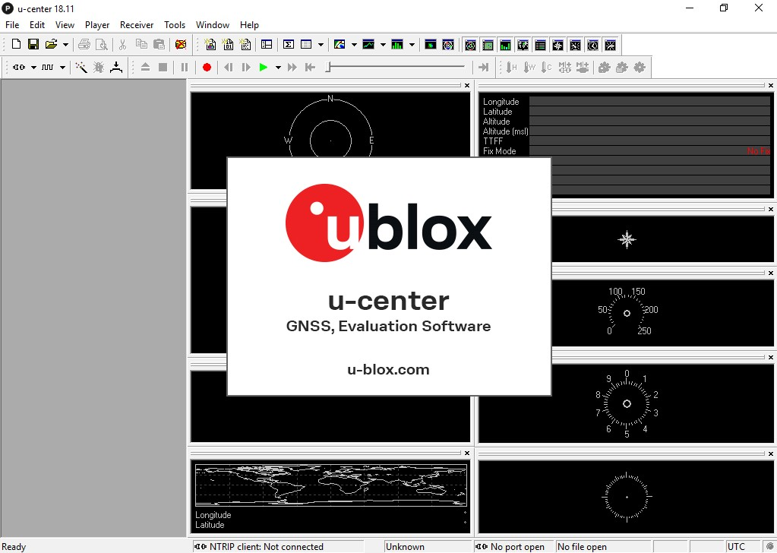

**Figure 1: Start display**

## 3.4 Connect to the receiver

### 3.4.1 Select the port

Locate the communication toolbar (Figure 2) and click on the arrow beside the  icon. This will show a list with all available COM ports (Figure 3). Select the corresponding COM port where the receiver is connected. If a link could be established, the icon will turn green and the text in the status bar changes from (in this example u-center is connected to COM6). This does not mean that the communication already works but only that the port could be opened.



to



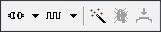

**Figure 2: Communication Toolbar**

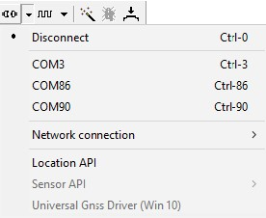

**Figure 3: List of available COM ports**

### 3.4.2 Select the baud rate (only for COM ports)

Again in the communication toolbar, click on the arrow beside the  icon. This will show a list with all available baud rates (Figure 4). Select the correct baud rate on which the receiver is communicating (typically 9'600 baud). If u-center is able to decode data from the receiver, the status bar begins to blink in green as shown in the following icon:  . This means that the connection is established successfully and the communication between the receiver and u-center is working.

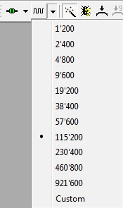

**Figure 4: List of available baud rates**

Now you are ready to use the receiver.

# 4 Concept and philosophy

Understanding the basic concept behind u-center is important in order to get the highest benefit out of this powerful evaluation software. Figure 5 depicts the architecture of the software. The program gets a data stream from either a communication port or a log file and splits this stream into protocol messages. From the messages, relevant parameters are extracted and inserted into the current dataset of the database that is used by the display and analysis features of the application.

In the current dataset, statistical values of the parameters are calculated. Average, minimum, maximum and standard deviation are calculated for most parameters. If the available messages do not provide a parameter, u-center tries to calculate the parameter from the ones that are available. For example if velocity-north and velocity-east are available, u-center calculates the speed over ground and course over ground, unless this data is already available in other messages.

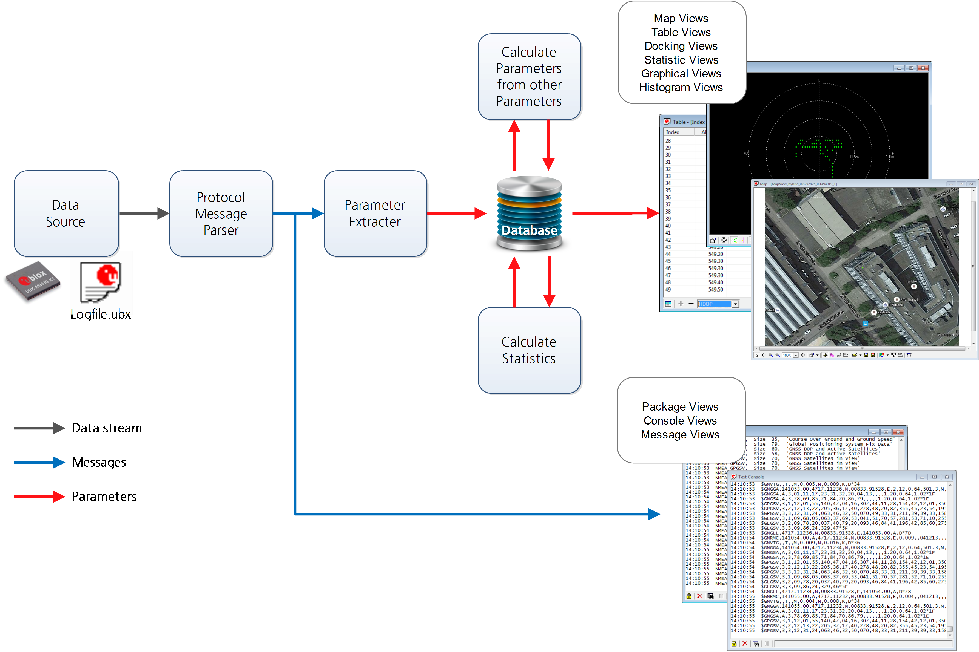

**Figure 5: Engine architecture**

The u-center database size may be adjusted. If the size is exceeded u-center keeps only the latest datasets and the oldest ones are removed. Refer to Database limitations for the details.

Very long recordings may decrease performance of u-center.

u-center provides various view classes (described below) for display and presentation. Most views take their data from the database, but some get their data directly from the message without using the database at all. The other views are updated when the database changes.

* **Message Views** display and decode a copy of every known message. These views allow observing a single message in detail and they may also be used to configure the GNSS device. Refer to Messages view for details. The configuration view is a subset of the message view and only displays message to configure the receiver.
* **Console Views** display the messages in text form. There is also a wide range of information available which is useful for evaluation and testing. Refer to sections Packet console, Binary console and Text console for details.
* **Graphical Views** display parameters from the database in graphical form. Charts (see Chart view), histograms (see Histogram view) and a map view (see Map view) can be created. There are two more views (deviation map and sky view, see Deviation map and Sky view) that may be used for statistical performance and antenna pattern analysis.
* **Tabular Views** show the parameters of the database in tabular form. They can be freely configured to allow customized tables. Refer to Table view and Statistic view for details.
* **Docking Windows** can be docked to the frame of u-center. An analog watch, compass, world map, altitude and speed meter are available. There are also docking windows showing the current signal power and the constellation of the satellites received by the device as well as a summary of the GNSS status.

Displaying various views and docking windows requires computing power. Minimizing or closing them may significantly reduce CPU usage.

## 4.1 Color and satellite coding scheme

In the graphical views and some docking windows, colors are used to indicate data quality. Table 1 shows the color codes for graphical views depending on the quality of the navigation solution.

**Color**

**Meaning**



Yellow

Current value



Orange

Valid 3D navigation fix + Dead Reckoning



Green

Valid 3D navigation fix



Cyan

Valid 2D navigation fix



Magenta

Dead Reckoning fix



Blue

Degraded navigation fix



Red

No or invalid navigation fix

**Table 1: Color-coding scheme for graphical views**

Table 2 gives the color-coding scheme for the docking windows and sky view. It indicates the state of each satellite.

|  |  |
| --- | --- |
| **Color** | **Meaning** |
| Green | Satellite used in navigation (with Ephemeris) |
| Olive | Satellite used in navigation (with Ephemeris and PPP) |
| Dark Green | Satellite used in navigation (with aiding data: AssistNow Autonomous, AssistNow Online/Offline) |
| Cyan | Satellite signal available, available for use in navigation |
| Blue | Satellite signal available, not available for use in navigation |
| Red | Satellite signal not available |

**Table 2: Color-coding scheme for the docking windows and sky view**

Table 3 gives the satellite-coding scheme for the docking windows and sky view. It indicates to which GNSS a satellite belongs.

|  |  |
| --- | --- |
| **Code** | **System** |
| Gxx | GPS |
| Rxx | GLONASS |
| Bxx | BeiDou |
| Exx | Galileo |
| Sxx | SBAS |
| Qxx | QZSS |

**Table 3: Satellite-coding scheme for the docking windows and sky view**

Figure 6 shows the Status Color configuration. This is available under: Tools > Preferences > Status Colors.

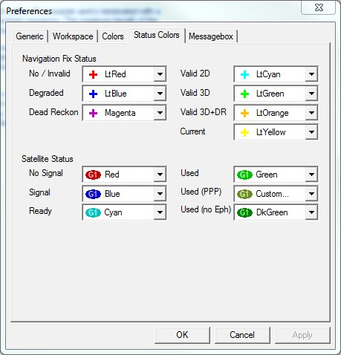

**Figure 6: Color-coding configuration**

## 4.2 Operating modes

u-center has different operating modes (see Figure 7). The mode changes when you open or close a log file or when you invoke the player. To be able to use the record mode you have to create a new file, save to a new file or open an existing file. The record and play mode are only available if you have created a new file or when you have opened a writable file.

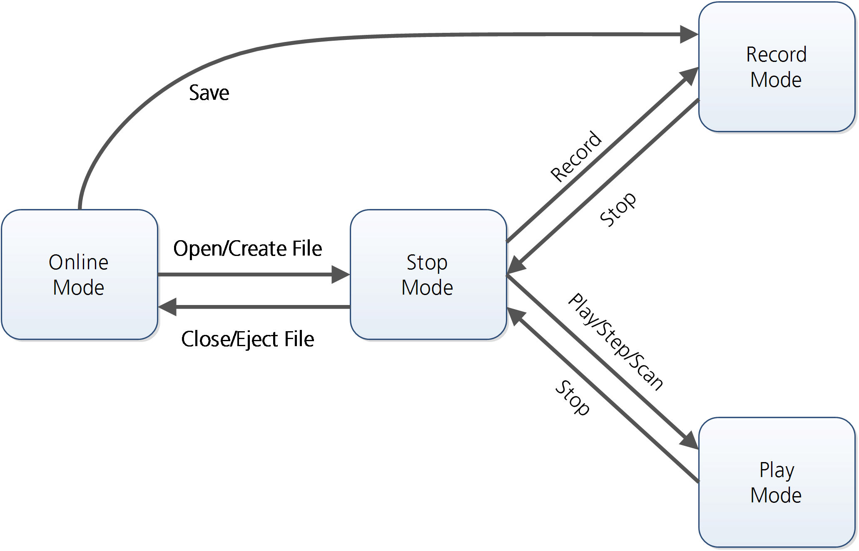

**Figure 7: Relation between operating modes**

### 4.2.1 Online mode

In this mode a GNSS device is directly connected to u-center via a COM port. u-center can control and configure the receiver and it will display the data that the receiver is sending periodically.

### 4.2.2 Stop mode

In this mode no data from a receiver or a log file is forwarded to the database and views. u-center is in this mode when a log file is open but player and recorder are not active.

### 4.2.3 Record mode

Record Mode is the same mode as the Online Mode, except u-center additionally creates a log file, concatenating all the messages sent by the receiver. You enter this mode by creating a new log file or opening an existing log file without write protection and pressing the record button. An example of using this mode would be to make overnight measurements and evaluate the data at a later time. u-blox customer support may request a log file from you when you are experiencing a problem with one of our receivers and will usually need this to be recorded with debug data enabled (see Receiver).

### 4.2.4 Play mode

The Play Mode allows replaying a previously recorded log file step by step, in real-time or at an accelerated rate. You enter this mode by opening a file and pressing the play, step or scan button.

### 4.2.5 Relations between modes

The operating mode depends on the status of the log file player. Modes are changed by user actions. Each mode has different states that are changed by a user action or by an event (see Figure 7). In **Online mode** and **Record mode**, u-center displays data from the receiver. In **Play mode** data from a log file is displayed. **Play mode** has different states:

* Play reads and displays messages periodically from the log file. The user interface is derived from that of a CD player. u-center updates the views after each message.
* Step gets one message from the log file and immediately returns to paused Play state.
* Scan reads messages periodically but the display is only updated when paused or by changing the state.

Position can be set in a log file. This behaves differently in **Play mode** and **Stop mode**. In **Stop mode** the position is just set and no data is read and displayed. u-center will start recording or playing from that position when changing the mode. If position is set in **Play mode**, u-center will load the data up to this position from the log file and display the contents.

### 4.2.6 Database limitations

The number of epochs displayed by views that show history (Table, Chart, Histogram, Sky, Satellite level history etc.) can be limited in order to allow an efficient analysis of large log files and not to consume too much disk space. There is a setting which controls this history database limit, which is available under: Tools > Preferences > General. By default the value for the number of epochs is set to 0, which means the database size is not limited. Any other number higher than 0 will limit the size of this history database. When this limit is set, then the oldest values will be discarded after the database reaches this limit size. Data stored to a log file is not affected by the database limitation.

Also controlled in Tools > Preferences > General is the max number of messages stored. This limit applies to how many messages from a log file can be loaded and are playable. The default value for this is set very high, but can be reduced to save disk space, or increased if a very large log file cannot be fully loaded.

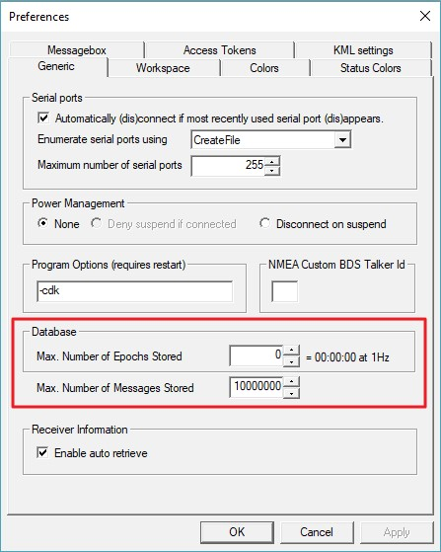

**Figure 8: Example of setting maximum number of epochs to keep in database**

For long-term observations, it is recommended to record the messages to a log file.

If a high value of epochs is selected, the display of data in real-time cannot be guaranteed, especially when graphical views are open.

### 4.2.7 Receiver information

u-center will try to retrieve some information about what kind of receiver is connected by sending UBX-MON-VER message on every successful connection. In this way certain functionality can automatically be disabled if it is not supported by the connected receiver. In some cases this might not be the desired behavior as it might hinder some other operation where these extra messages are not desired. There is a setting that controls if receiver information is auto-retrieved or not, and that is available under: Tools > Preferences > General. By default the auto retrieval is enabled.

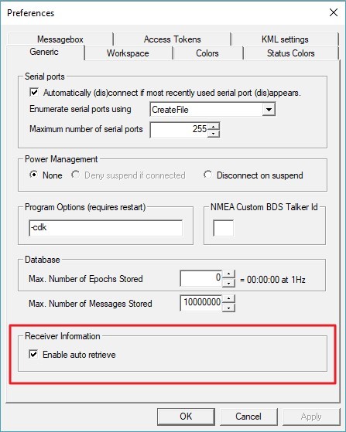

**Figure 9: Enabling/disabling automatic receiver information retrieval**

# 5 u-center menus and windows

## 5.1 Main frame and toolbars

The main frame is the primary display screen of u-center. It displays all tool bars and some of the information provided by the device. In the standard status bar, information about communication, UTC time, connection time, used protocol (NMEA or UBX), used file, etc. is shown.

**Button tool tip**: A description about each button in the toolbars can be obtained by holding the mouse cursor over the button for a few seconds. A tool tip message will appear near the icon with additional information while a detailed description is displayed in the status display.

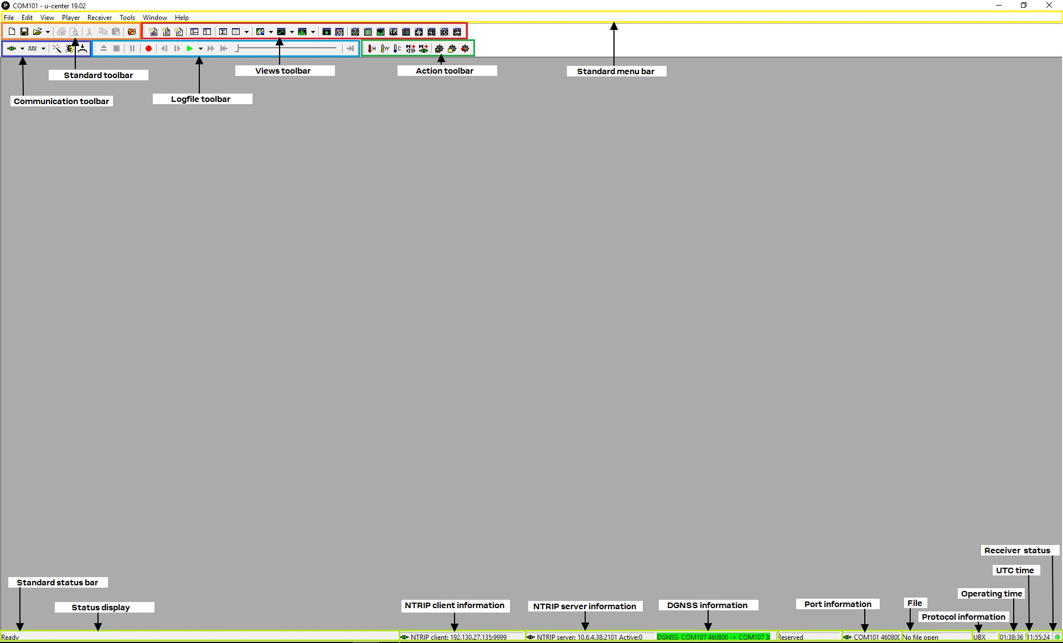

**Figure 10: u-center main frame and toolbars**

### 5.1.1 Standard menu bar

All u-center functions can be accessed through the standard menu bar. Commands can also be accessed by shortcuts that are listed in the menus. Some often used operations are also available in the different toolbars.

##### 5.1.1.1 File

Creates a new log file. No data is yet written but only the file is opened. The duration of the logging time is displayed in the status bar field Operating time.

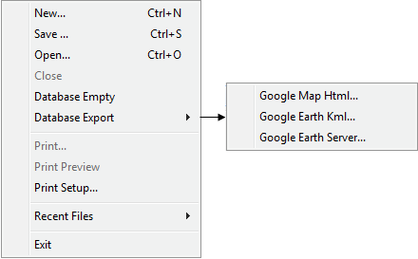

**Figure 11: File menu entries**

**Function**

**Description**

**Shortcut /**

**Toolbar icon**

**New...**

Ctrl+N /



|  |  |  |
| --- | --- | --- |
| **Save...** | Creates a new log file, saves the data from the internal database to the log file and starts immediately recording all new data from the receiver. This is useful when an error or an unexpected event occurred and no log file was recorded. The size of the ring buffer (4 MB) is large enough to retain the data for the last hour (approx.). | Ctrl+S / |
| **Open...** | Opens a stored log file to be replayed. | Ctrl+O |

**Close** Closes the active file. Ctrl+E / 

|  |  |  |
| --- | --- | --- |
| **Database Empty** | Deletes the internal database and all saved values. |  |
| **Database Export** | Exports the internal database into HTML or KML data formats for displaying with Google Map or Google Earth. |  |
| **Google Map Html...** | Exports the internal database into HTML data format for displaying with Google Map. |  |
| **Google Earth Kml...** | Exports the internal database into KML data format for displaying with Google Earth. |  |
| **Google Earth Server...** | Starts u-center's Google Earth server which allows continuous and real time tracking to be visualized in Google Earth. |  |
| **Print...** | Prints the active document. |  |
| **Print Preview** | Shows a preview of the print output. |  |
| **Print Setup...** | Shows the setup dialog of the printer. |  |
| **Recent Files** | Lists all recently used files. |  |
| **Exit** | Exits u-center. | Ctrl+F4 |

**Table 4: File menu entries**

##### 5.1.1.2 Edit

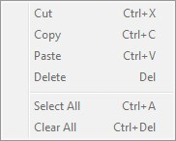

**Figure 12: Edit menu entries**

**Function**

**Description**

**Shortcut /**

**Toolbar icon**

**Cut**

Cut the current selection and put in to the clipboard.

Ctrl+X / Shift

+

Del /



|  |  |  |
| --- | --- | --- |
| **Copy** | Copy the current selection to the clipboard. | Ctrl+C / Ctrl-  Insert / |
| **Paste** | Paste the clipboard content to the current position. | Ctrl+V / Shift  +Insert / |
| **Delete** | Delete the current selection. | Del |
| **Select All** | Select all in the current view. | Ctrl+A |
| **Clear All** | Clear all in the current view. | Ctrl+Del |

**Table 5: Edit menu entries**

##### 5.1.1.3 View

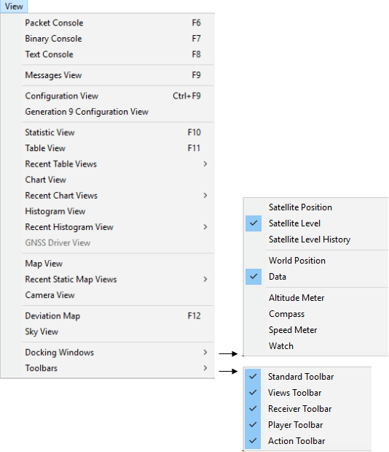

**Figure 13: View menu entries**

|  |  |  |
| --- | --- | --- |
| **Function** | **Description** | **Shortcut /**  **Toolbar icon** |
| **Packet Console** | Opens the packet console. | F6 / |
| **Binary Console** | Opens the binary console. | F7 / |
| **Text Console** | Opens the text console. | F8 / |

**Messages View** Opens the dialog with all supported messages. F9 /

**Configuration View** Opens the dialog with all configuration messages. This is a subset of the Ctrl-F9 / Messages View.



**Generation 9** Opens the dialog for Generation 9 Advance configuration view. All the Generation **Configuration View** 9 receivers should be configured with this new dialog.

**Statistic View** Opens the statistic view with all data from the internal database. F10 /

**Table View** Opens the empty table view. All values from the internal database can be F11 /

displayed individually.

**Recent Table View** Lists all the table views that have been opened. This information comes from the Windows registry and is also valid after a restart of u-center.

**Map View** Opens a window allowing to display a map.

**Recent Map View** Lists all the maps views that have been opened. This information comes from the Windows registry and is also valid after a restart of u-center.

|  |  |  |
| --- | --- | --- |
| **Function Description** | | **Shortcut /**  **Toolbar icon** |
| **Chart View** Opens a window with chart functionality. All values from the internal database can be displayed individually. | |  |
| **Recent Chart View** Lists all the chart views that have been opened. This information comes from the Windows registry and is also valid after a restart of u-center. | |  |
| **Histogram View** Opens a window with histogram functionality. All values from the internal database can be displayed individually. | |  |
| **Recent Histogram View** Lists all the histogram views that have been opened. This information comes from the Windows registry and is also valid after a restart of u-center. | |  |
| **Camera View** | Opens a window allowing to connect to a web cam and visualize and save the image. |  |
| **Deviation Map** | Opens a window with a position deviation map. | F12 / |
| **Sky View** | Opens a window with the sky view. The current position of the satellites and their values from the internal database are shown. |  |
| **Docking Windows** | Opens a list with all available docking windows that can be shown. |  |
| **Satellite Position** | Shows or hide the current satellite positions. |  |
| **Satellite Level** | Shows or hide the current satellite levels. |  |
| **Satellite Level History** | Shows or hide the history of the satellite levels. |  |
| **World Position** | Shows or hide the current position on the world map. |  |
| **Data** | Shows or hide data from the navigation solution (like position, TTFF, accuracy and DOPs). |  |
| **Altitude Meter** | Shows or hide the altitude meter. |  |
| **Compass** | Shows or hide the compass. |  |
| **Speed Meter** | Shows or hide the speed meter. |  |
| **Watch** | Shows or hide the clock. |  |
| **Toolbars** | Opens a list with all available toolbars that can be shown. |  |
| **Standard Toolbar** | Shows or hide the standard toolbar. |  |
| **Views Toolbar** | Shows or hide the views toolbar. |  |
| **Receiver Toolbar** | Shows or hide the receiver toolbar. |  |
| **Player Toolbar** | Shows or hide the player toolbar. |  |
| **Action Toolbar** | Shows or hide the action toolbar. |  |

**Table 6: View menu entries**

##### 5.1.1.4 Player

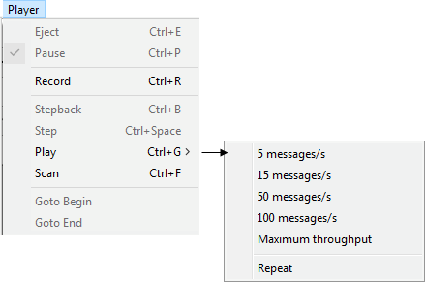

**Figure 14: Player menu entries**

**Function**

**Description**

**Shortcut /**

**Toolbar icon**

**Eject**

Closes the active log file.

Ctrl+E /



**Pause**

Pauses reading or recording from the active log file.

Ctrl+P /



**Record**

Starts recording to a new or already opened log file. Any data in the internal

database will not be written to the file. If you want to save this data into a log file,

open the File menu and click Save. To stop recording, press the same button.

Ctrl+R /



**Stepback**

Single step function. The previous message is read.

Ctrl+B /



**Step**

Single step function. The next message is read.

Ctrl+Space /



**Play**

Starts reading from the active log file. The speed of the action can be chosen on

the sub-menu.

Ctrl+G /



**Scan**

Reads the entire log file into the database and updates the display at the end of

the scan period.

Ctrl+F /



**Goto Begin**

Sets the read position to the beginning of the log file.



**Goto End**

Sets the read position to the end of the log file.



**Table 7: Player menu entries**

##### 5.1.1.5 Receiver

Defines the port u-center connects to. The list is generated automatically using the enumeration method under Tools > Preferences > Generic > Serial ports. The currently used port will be indicated.

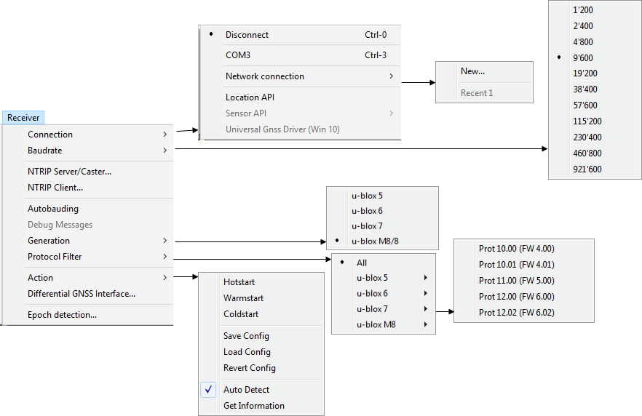

**Figure 15: Receiver menu entries**

**Function**

**Description**

**Shortcut /**

**Toolbar icon**

**Connection**



|  |  |  |
| --- | --- | --- |
| **Disconnect** | Disconnects from a connected receiver. |  |
| **COMx** | Connects to COMx with the current baud rate. | Ctrl+[1...9]  (if available) |
| **Network connection** | Connects to a receiver through network. |  |
| **Location API** | Connects to the receiver using the Location API available in windows 7 onwards. |  |
| **Sensor API** | Connects to the receiver using the Sensor API in Windows 7 and Windows 8 (the USB Sensor driver is required in this case) but not in Windows 10. |  |

**Baud rate** Defines the baud rate of the communication. The list is predefined and cannot be changed. The currently set baud rate will be indicated.

|  |  |  |  |
| --- | --- | --- | --- |
| **NTRIP Server/Caster** | Enables u-center to act as a NTRIP server. | | |
| **NTRIP Client** | Enables u-center to act as a NTRIP client. | | |
| **Autobauding** | Enables or disables autobauding for the current communication with the receiver. | | |
| **Debug Messages** | Enables all debug messages in the receiver. Can be requested from u-blox support. | | |
| **Generation** | Defines the generation of the attached u-blox GNSS receiver. u-center also tries to detect automatically the correct generation. | | |
| **Protocol Filter** | Sets the message filter against versions of protocol specification. | | |
| **Action** | Lists all possible actions that can be performed with the u-blox GNSS receiver. | | |
| **Function** | **Description** | | **Shortcut /**  **Toolbar icon** |
| **Hot start** | Sends a hot start command to the receiver. No data is deleted in the receiver. | |  |
| **Warm start** | Sends a warm start command to the receiver. Only the ephemeris are deleted from the memory. | |  |
| **Cold start** | Sends a cold start command to the receiver. All information is deleted from the memory. | |  |
| **Save Config** | Saves the current receiver configuration to the memory so that it will be loaded after a restart. | |  |
| **Load Config** | Loads the last saved configuration from the memory. | |  |
| **Revert Config** | Deletes all configurations in the memory and reverts the receiver to the default configuration. | |  |
| **Auto Detect** | Enable/Disables the automatic polling of the UBX-MON-VER message to allow ucenter to obtain information about the receiver. On receiving the message, the receiver information contained within the message is extracted, stored and used by u-center for any receiver specific features. Having this feature enabled allows u-center to automatically be aware of the type of receiver attached. Disabling this feature might be useful when the random appearance of UBX-MON-VER messages could interfere with the current users task. |
| **Get Information** | Manually polls the receiver for a UBX-MON-VER message. On receiving the message, the receiver information contained within the message is extracted, stored and used by u-center for any receiver specific features. Typical use would be when the users need auto detection disabled, but would like u-center to be aware of the connected receiver's details. |

|  |  |
| --- | --- |
| **Differential DGNSS Interface…** | Allows the streaming of RTCM messages to the receiver for high precision applications. |
| **Epoch detection…** | Defines which time information determines the boundary of an epoch detection in u-center (see Change epoch detection method). |

**Table 8: Receiver menu entries**

##### 5.1.1.6 Tools

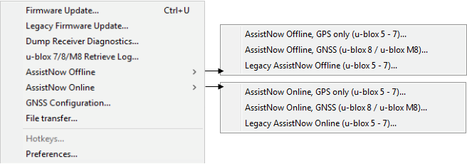

**Figure 16: Tools menu entries**

Some of the menu items will only be displayed when the correct receiver generation is connected and identified by u-center. If you cannot select one option, change the receiver generation under Receiver > Generation.

|  |  |
| --- | --- |
| **Function Description** | **Shortcut /**  **Toolbar icon** |
| **Firmware Update u-blox** Opens the firmware update dialog for u-blox 5 - 8 generation receivers.  **5 - 8...** | Ctrl+U |
| **Dump Receiver** Tool to create the receiver diagnostic. Can be requested by the u-blox support  **Diagnostics...** team. |  |

|  |  |  |
| --- | --- | --- |
| **Function** | **Description** | **Shortcut /**  **Toolbar icon** |
| **u-blox 7/8/M8 Retrieve Log...** | Opens the dialog to download log information from the receiver. This is supported only since u-blox 7 receivers. |  |
| **AssistNow Offline** | Opens the AssistNow Offline dialog. Please switch over to AssistNow Offline as the Legacy AssistNow Offline service is marked deprecated. |  |
| **AssistNow Online** | Opens the AssistNow Online dialog. Please switch over to AssistNow Online as the Legacy AssistNow Online service is marked deprecated. |  |
| **GNSS Configuration...** | Opens the dialog to save the receiver configuration to a file on the PC or to restore a configuration from a file on the PC. |  |
| **File transfer...** | Opens the dialog to transfer a file to the receiver. |  |
| **Preferences...** | Opens the dialog for the u-center preferences. |  |
| **Table 9: Tools menu entri**  **5.1.1.7 Window**    **Figure 17: Window menu** | **es**  **entries** |  |
| **Function** | **Description** | **Shortcut /**  **Toolbar icon** |
| **Cascade** | Arranges all open dialogs cascaded. |  |
| **Tile Horizontally** | Arranges all open dialogs horizontally. |  |
| **Tile Vertically** | Arranges all open dialogs vertically. |  |
| **Close All** | Closes all open dialogs and windows. |  |
| **Save Workspace As...** | Saves the position of the open dialogs and windows to a file on the computer. |  |
| **Restore Workspace From...** | Restores the position of the dialogs and windows from a file on the computer. |  |
| **Recent Workspace** | Lists all recently used workspace files. |  |
| **Arrange Icons** | Arranges the icons at the bottom of the window. |  |
| **List of dialogs and windows** | Lists all visible and hidden dialogs and windows in u-center. |  |
| **Table 10: Window menu e**  **5.1.1.8 Help**    **Figure 18: Help menu ent** | **ntries**  **ries** |  |
| **Function** | **Description** | **Shortcut /**  **Toolbar icon** |
| **Contents...** | Gives a reference to this user guide. | F1 |
| **Function** | **Description** | **Shortcut /**  **Toolbar icon** |
| **About u-center...** | Shows the about dialog with the software version and the used libraries and their versions. |  |

**Table 11: Help menu entries**

### 5.1.2 Standard toolbar

The standard toolbar gives access to standard operations like opening and saving files, print the current view or empty the database.

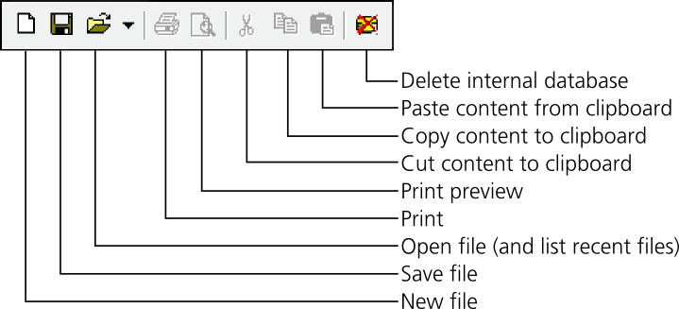

### 5.1.3 Views toolbar

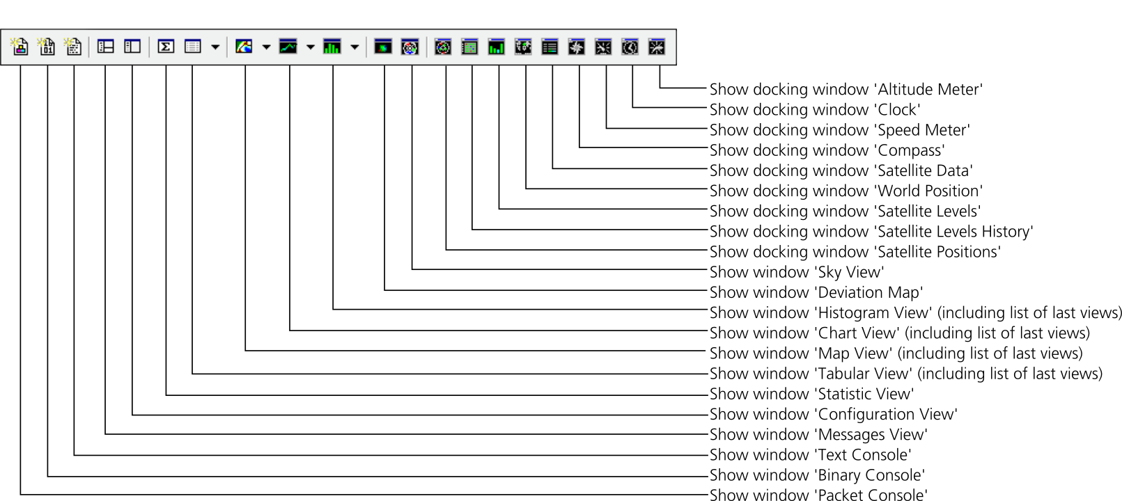

### 5.1.4 Communication toolbar

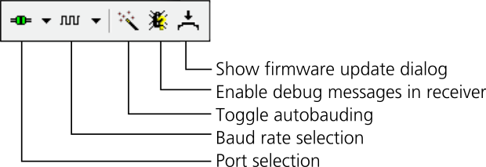

### 5.1.5 Logfile toolbar

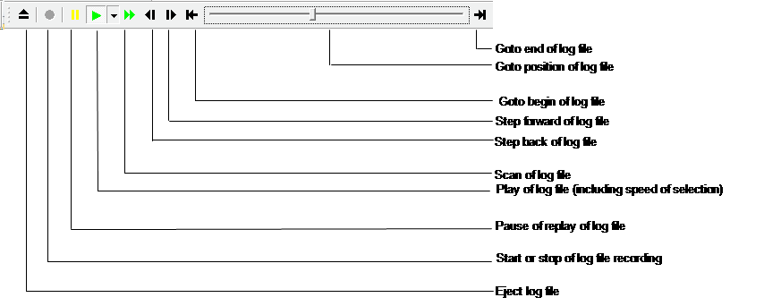

### 5.1.6 Action toolbar

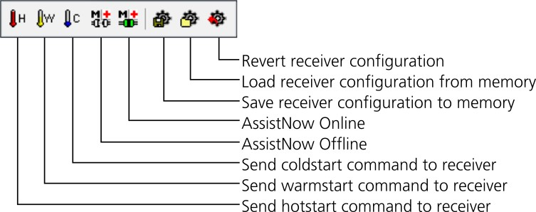

### 5.1.7 Standard statusbar

The standard status bar is updated automatically and shows the information about the opened file, the connection and the time. The following fields are available:

**Status display**: Displays the current action or the function of a button if the mouse cursor is over the button.

**NTRIP client information**: Shows the connection to an NTRIP caster (only when activated through Receiver > NTRIP Client...). Clicking on it will show up to 100 of the last errors between u-center and connected NTRIP caster.

**NTRIP server information**: Shows the status and number of clients currently connected to ucenter's NTRIP caster (only when activated through Receiver > NTRIP Server/Caster...). Clicking on it will show up to 100 of the last errors between u-center's NTRIP caster and connected clients.

**DGNSS information**: Shows the connection to a DGNSS source (only when activated through Receiver > Differential GNSS Interface...).

**Receiver generation**: u-center tries to automatically detect the type of device connected and activates the appropriate mode of operation in order to take optimal advantage of the features. The mode can also be manually selected through the menu bar (Receiver > Generation).

**Port information**: Shows the active COM port and baud rate. Color coding of the icon:

 Disconnected

 Waiting for first data

 Data is being received but errors are detected (mostly because of wrong baud rate settings)

 Last data received was valid but there is no data to collect at this time

 No data is being received but errors have been detected in the past

 Data is being received and collected at the correct baud rate

**File**: The file opened in the u-center player.

**Protocol information**: This box indicates the current message set that is being used to communicate with the device.

**Operating time**: The time elapsed since you started u-center.

**UTC time**: The current time sent by the device. This field is only updated if a receiver is connected.

**Receiver status**: Shows the last known status of the receiver. Color coding of the icon:

 Power status of receiver is unknown

 Receiver is powered on  Receiver is powered off

## 5.2 Views and windows

### 5.2.1 Packet console

The packet console lists all incoming and outgoing messages, and provides information about message length and type. The direction of the message is shown in the following way:

R <- Indicates the message was sent to the receiver

R -> Indicates the message came from the receiver

L -> Indicates the message came from the log file

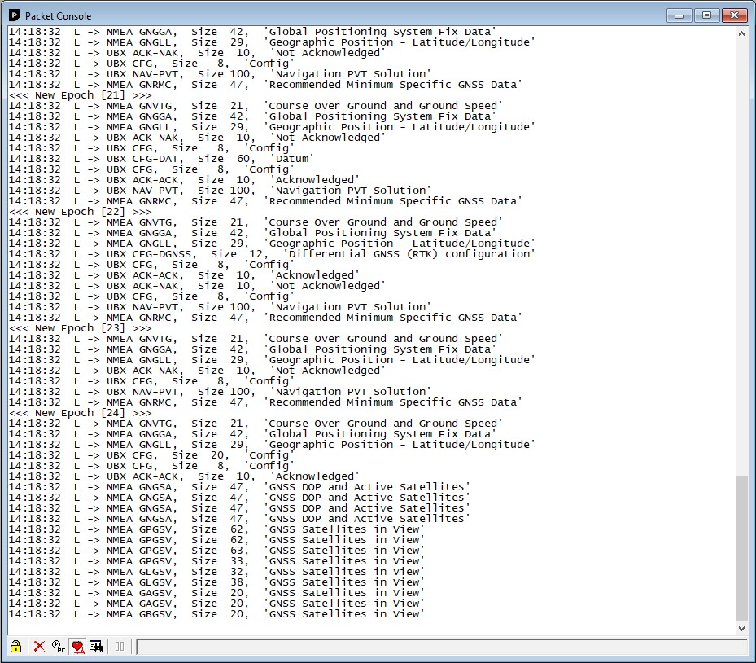

**Figure 19: Packet console**

Refer to Table 12 for an explanation of the icons and text field.

### 5.2.2 Binary console

The binary console lists all incoming messages in binary and ASCII format.

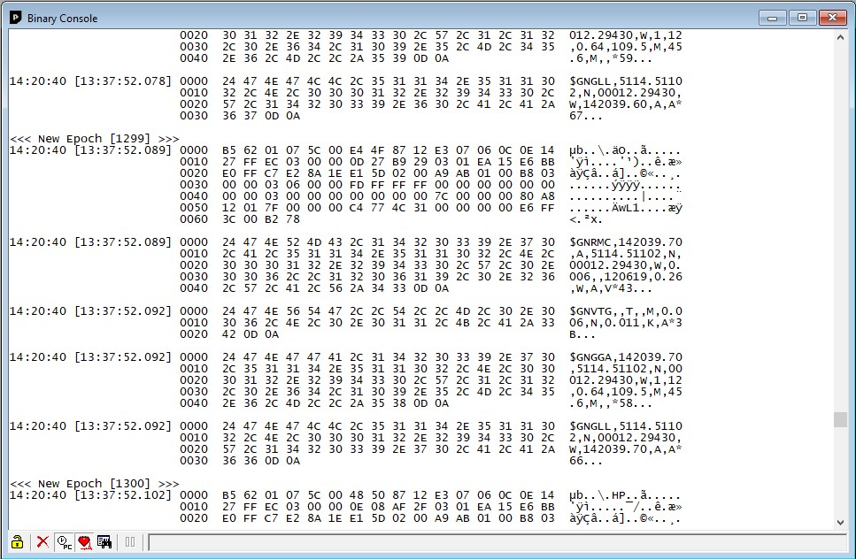

**Figure 20: Binary console**

Refer to Table 12 for an explanation of the icons and text field.

### 5.2.3 Text console

The text console displays the content messages in textual form such as UBX-INF or NMEA messages.

NMEA messages are shown with heading $Gxyyy, where x stands for the satellite system (P = GPS, SBAS, QZSS, L = GLONASS, A = Galileo, B = BeiDou, N = Any combination of GNSS) and yyy for the type of message (e.g. ZDA=Time & Date).

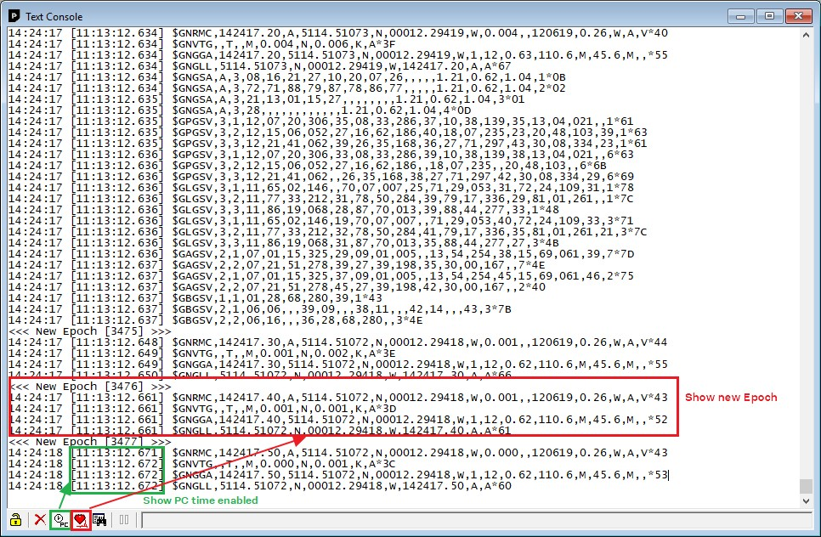

**Figure 21: Text console displaying UBX-INF and NMEA messages with "Show PC Time" and "Show/hide epoch markers" enabled**

Refer to Table 12 for an explanation of the icons and text field.

### 5.2.4 Icons and text field of console views

**Element**

**Name**

**Description**



/



Lock / Locked

Prevents the console from being updated with new data when locked. Pause key can

be used to Lock/Unlock the current console window.



Clear All

Erases all data in the console.



Show/Hide PC time

Shows/Hides the PC time in the console.



Show/Hide epoch

markers

Shows/Hides text for every new epoch with enumeration.



Filter on/off

Filters unwanted data from the data stream. This allows searching for certain

expression, e.g. all RMC messages.



Pause player

Pauses the player when the search expression is found. Only works in playback mode.

**Table 12: Description of the buttons and text field of the console views**

### 5.2.5 Regular expression evaluation

Normally, when you search for a sub-string in a string, the match should be exact. So if we search for a sub-string "abc" then the string being searched should contain these exact letters in the same sequence for a match to be found. We can extend this kind of search to a case insensitive search where the sub-string "abc" will find strings like "Abc", "ABC" etc. That is, the case is ignored but the sequence of the letters should be exactly the same. Sometimes, a case insensitive search is also not enough. For example, if we want to search for numeric digit, then we basically end up searching for each digit independently. This is where regular expressions come in to our help. Regular expressions are text patterns that are used for string matching. Regular expressions are strings that contain a mix of plain text and special characters to indicate what kind of matching to do. Here's a very brief tutorial on using regular expressions.

Suppose, we are looking for a numeric digit then the regular expression we would search for is "[0-9]". The brackets indicate that the character being compared should match any one of the characters enclosed within the bracket. The dash (-) between 0 and 9 indicates that it is a range from 0 to 9. Therefore, this regular expression will match any character between 0 and 9, that is, any digit. If we want to search for a special character literally we must use a backslash before the special character. For example, the single character regular expression "\*" matches a single asterisk. In the table below the special characters are briefly described. A regular expression search is case-sensitive.

|  |  |
| --- | --- |
| **Character** | **Description** |
| ^ | Beginning of the string. The expression "^A" will match an "A" only at the beginning of the string. |
| [^ | The caret (^) immediately following the left-bracket ([) has a different meaning. It is used to exclude the remaining characters within brackets from matching the target string. The expression "[^0-9]" indicates that the target character should not be a digit. |
| $ | The dollar sign ($) will match the end of the string. The expression "abc$" will match the sub-string "abc" only if it is at the end of the string. |
| | | The alternation or logic OR character (|) allows either expression on its side to match the target string. The expression "a|b" will match "a" as well as "b". |
| . | The dot (.) will match any character. |
| * | The asterisk (*) indicates that the character to the left of the asterisk in the expression should match 0 or more times. |
| + | The plus (+) is similar to asterisk but there should be at least one match of the character to the left of the + sign in the expression. |
| ? | The question mark (?) matches the character to its left 0 or 1 times. |
| () | The parenthesis affects the order of pattern evaluation. |
| [] | Brackets ([ and ]) enclosing a set of characters indicates that any of the enclosed characters may match the target character. |

**Table 13: Regular expression syntax**

##### 5.2.5.1 Examples

Let's assume that the lines in Figure 22 would appear in the NMEA console without filtering.

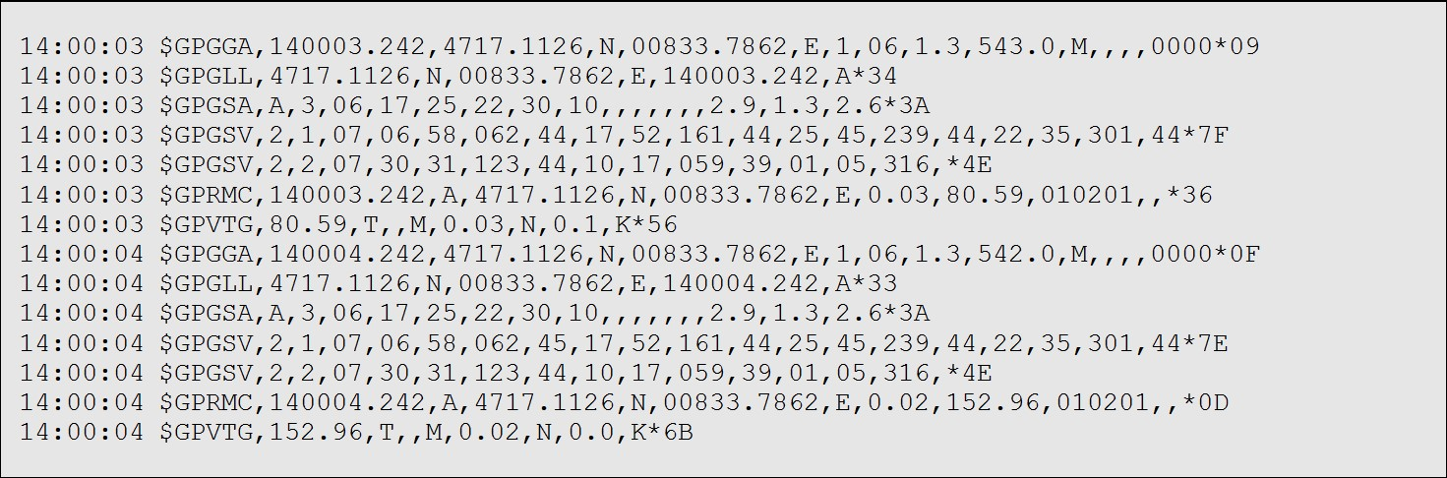

**Figure 22: Regular Expression Template**

**5.2.5.1.1 Example 1**

Searching for the RMC with a valid position and all GGA Messages:

##### GP(GGA|RMC,.*,A,)"

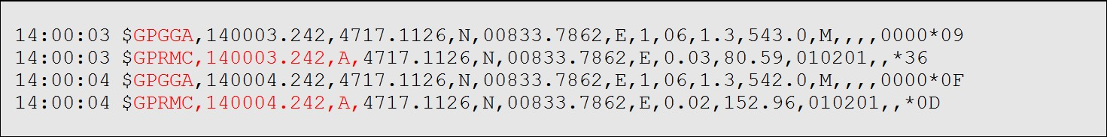

**Figure 23: Regular Expression Example 1**

**5.2.5.1.2 Example 2**

Searching for all GSV with the message index of "2" or "3":

##### GSV,.*,[2-3],



**Figure 24: Regular Expression Example 2**

###### 5.2.5.1.3 Example 3

Searching for all messages starting with $GP, which have a "G" in the message identifier but not at the first position:

##### ^\$GP.+G.*,

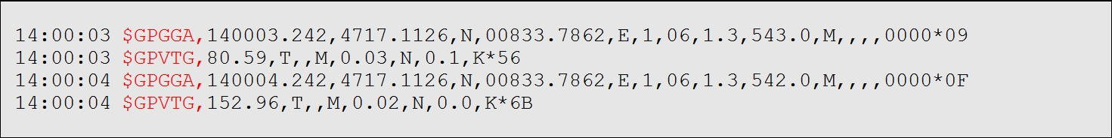

**Figure 25: Regular Expression Example 3**

**5.2.5.1.4 Example 4**

Searching for all messages having a checksum of which the higher nibble is 3

##### \*3.$

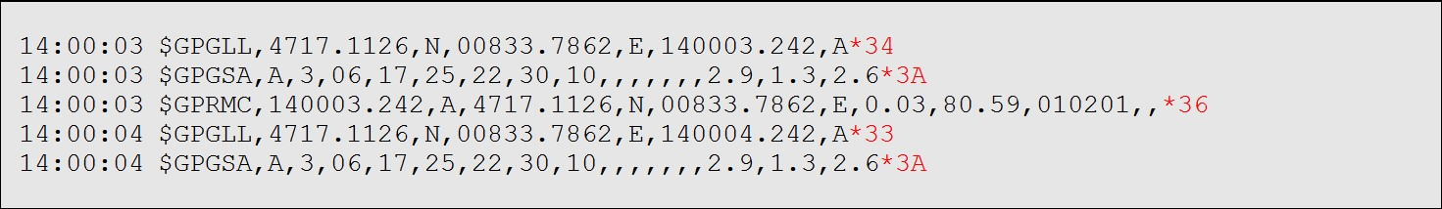

**Figure 26: Regular Expression Example 4**

### 5.2.6 Messages view

The messages view is utilized to communicate with the device. Receiver output messages (e.g. navigation output, status and debug information) are displayed; input messages (e.g. configuration messages) can be sent. There are different sections for NMEA and UBX protocol. See Figure 27 for an overview of the different elements in the messages view.

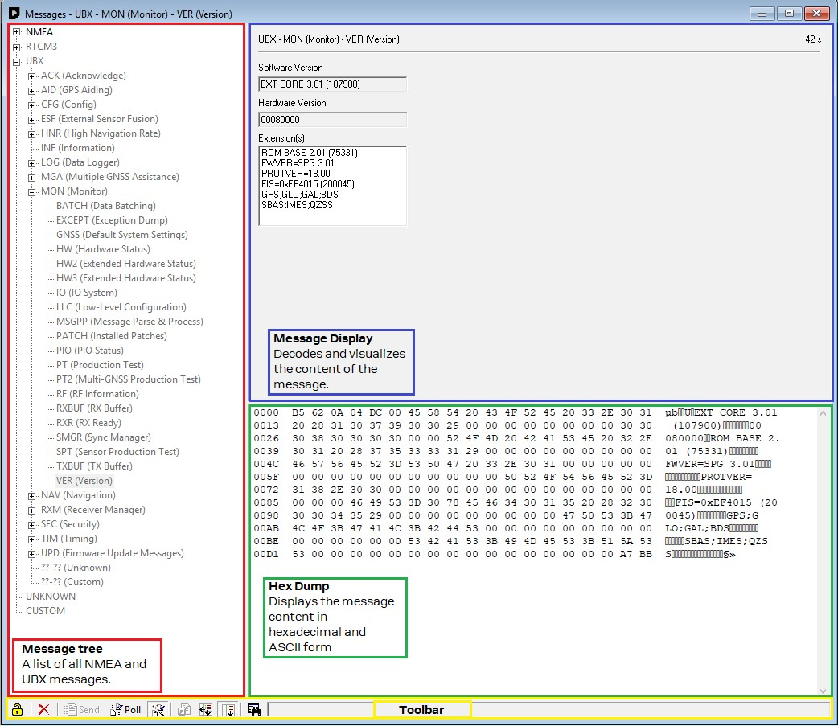

**Figure 27: Messages view**



/



Lock /

Locked

Prevents the message view from being updated with new data when locked. Pause key can be used

to Lock/Unlock the current view window.



Clear All

Erases the entire message view.



Send

Sends the current message to the device.



Poll

Polls the selected message once.



Auto poll

Automatically polls a newly selected message once.



Message

Hotkey

Assigns a hotkey to the selected message.

**Table 14: Description of the buttons in the messages view toolbar**

##### 5.2.6.1 Receiver output messages

Double-clicking on an output message enables or disables the periodic message update if the communication protocol is active. This feature is currently only supported for the UBX protocol.

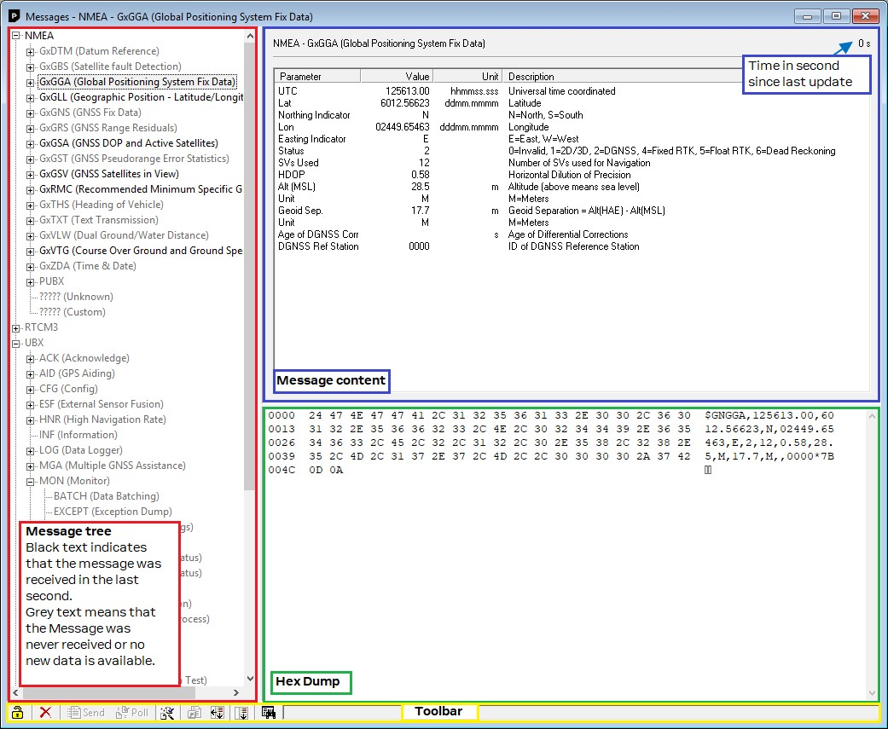

**Figure 28: Message display of an output message**

### 5.2.7 Generation 9 configuration view

The new u-blox Generation 9 configuration view allows the users to check the current configuration of the receiver and change it if needed. This view can only be used to configure u-blox 9 generation receivers.

By default, the configuration values being edited come from (and can be written back to) an attached receiver. This view consists of two different sub-views, GNSS Configuration and Advanced Configuration.

##### 5.2.7.1 GNSS configuration

This GNSS configuration sub-view enables the users to poll and configure the basic and advanced GNSS system configurations of the attached receiver. This sub-view describes sections below:

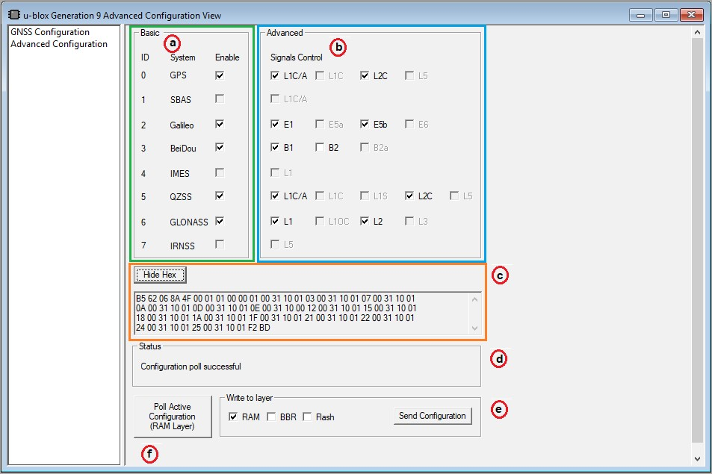

**Figure 29: u-blox Generation 9 Advanced Configuration View**

Basic This section shows the GNSS constellation configuration of the receiver by pressing

**Poll Active Configuration**. The receiver’s GNSS constellations can also be configured by enabling/disabling the required satellite constellations, and then pressing **Send Configuration**. See position **a**.

Advanced This section shows the GNSS constellation signal information configured in the

receiver by pressing **Poll Active Configuration**. The receiver’s GNSS signals can also be configured by enabling/disabling the required signals, and then pressing **Send Configuration**. See position **b**.

Show Hex/ Hide Hex Shows or hides the hex values that make up the messages describing the receiver configuration just sent or received. See position **c**.

Status Shows the status of the action taken. See position **d**.

Write to layer Once selected the desired layer, **Send configuration** button sends the GNSS

constellation and signal information to the receiver. See position **e**.

Poll Active Configuration (RAM Polls the GNSS constellation and signal configuration from RAM layer of the attached

Layer) receiver. See position **f**.

**Table 15: Description of the buttons and sections in the GNSS Configuration sub-view**

##### 5.2.7.2 Advanced Configuration

In the Advanced Configuration sub-view, all groups of configuration items are displayed in a tree structure. Expanding a group will show the RAM layer values for all readable configuration items in that group. Each item is read individually from the receiver as the group is expanded. Some item values may not be known to the receiver in which case the value will be shown as "-".

If no receiver is attached or if the receiver does not support the new configuration concept then no values will be visible. If the receiver is not responding for some reason then close the group and open it again to retry.

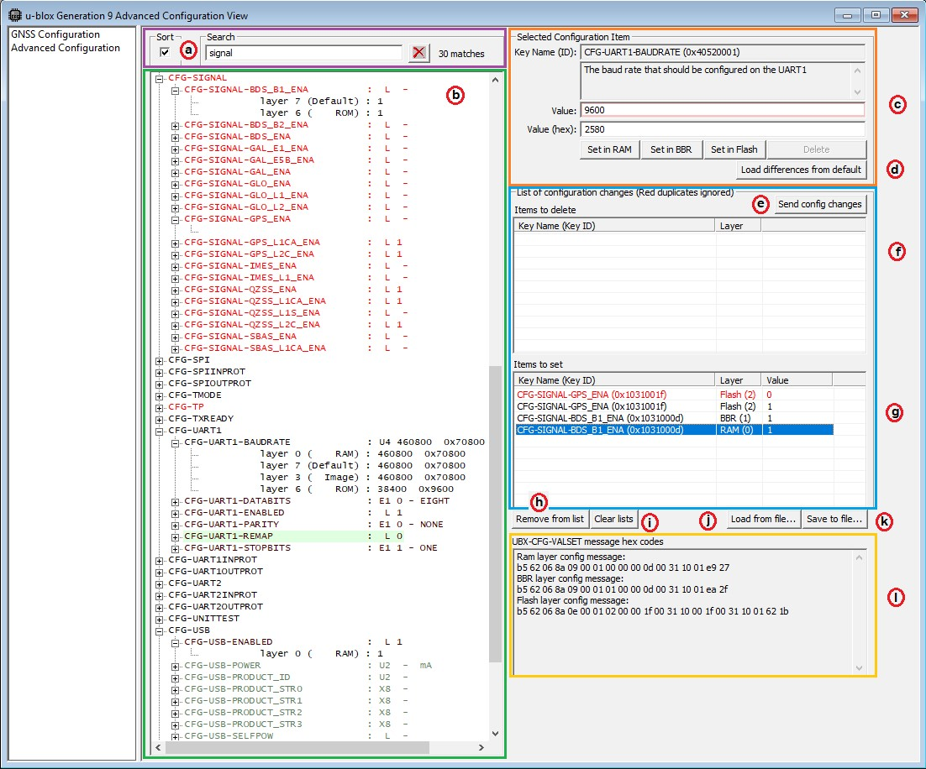

**Figure 30: Advanced Configuration view**

Users can expand items of interest and u-center will attempt to read values for all the other layers such as BBR, flash, ROM, pin, etc. and display any that it finds. This sub-view contains sections below:

|  |  |
| --- | --- |
| Configuration item search | To search for an item by name, type into the search text box just above the tree. The search is case-insensitive. See position **a**. |
| Configuration item tree view | All entries that contain the search text will be highlighted in red. The search will check for a match in group and item names, titles and descriptions. If a group contains an item which matches then the group will be highlighted as well. See position **b**. |
| Selected Configuration Item | This section describes the selected item in more detail. The field having the searched item is shown in red. See position **c**. |
| Load differences from default | Click on **Load receiver differences from default** to read the configuration values set in the receiver. This can be used to duplicate the current settings in another receiver. The operation depends on the working mode of the tool. If used in the normal, attached to receiver mode then the "writes" list will be populated with any settings in the FS or BBR layers. See position **d**. |
| Send config changes | "Send config changes" will send the current set of settings to the attached receiver. A tick will appear next to the items which were successfully altered in the receiver.If the receiver does not acknowledge the request, a cross appears. If there is no tick or a cross, the receiver does not respond to the request. Items are sent in groups of values to be sent to the same layer. If one value for a layer cannot be written, then all values for that layer will fail to be written and will show a cross. See position **e**. |
| Items to delete | If an item that can be deleted from the receiver (if it is in the BBR or Flash layers) is selected from the tree, then a button **Delete** will appear. If that button is selected then it will be added to the list of deletions shown in the "Items to delete" section on the right of the tree. See position **f**. |
| Items to set | If a writable layer item is selected, then press one of the layer buttons to add write operations to a list of item writes. A value can be changed by clicking on it in the top left sub-view area before writing. If two values for the same item are selected in the same layer, then the earlier one will be highlighted in red to show that it will be ignored as a duplicate setting. See position **g**. |
| Remove from list | Removes the selected item from one of the lists. See position **h**. |
| Clear lists | Removes all the items from all the lists. See position **i**. |
| Load from file... | Loads a group of settings from a readable text file. See position **j**. |
| Save to file... | To save the current list of settings to a readable text file, click **Save to file...** and choose a file path. This will produce a file in the ASCII format. See position **k**. |
| Message hex codes | Lists the hex values for the UBX-CFG-VALSET message that will be constructed for setting the selected configuration properties. See position **l**. |

**Table 16: Description of the buttons and sections in the Advanced Configuration sub-view**

### 5.2.8 Statistic view

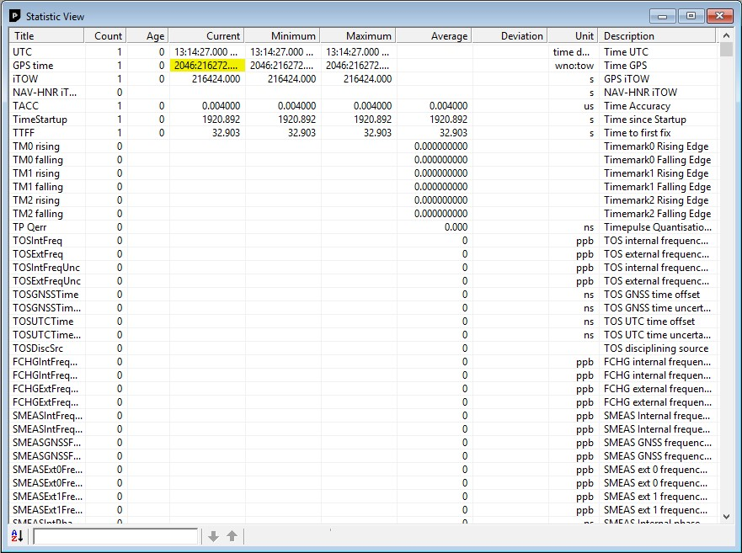

**Figure 31: Statistic view**

All available database values (transmitted from the device or calculated by u-center) are displayed. The following statistics are displayed:

* Current value
* Minimum value
* Maximum value
* Average value
* Standard Deviation

The following color scheme for the values is applied:

* Grey color: The value was not set for the current epoch
* Blue color: The value was calculated by the application from other data
* Empty field: No data is available

Choosing "Database Empty" in the file menu or pressing the button  clears the statistic view.

The content of the statistic view can easily be exported to other programs using Copy/ Paste.

#### 5.2.9 Table view

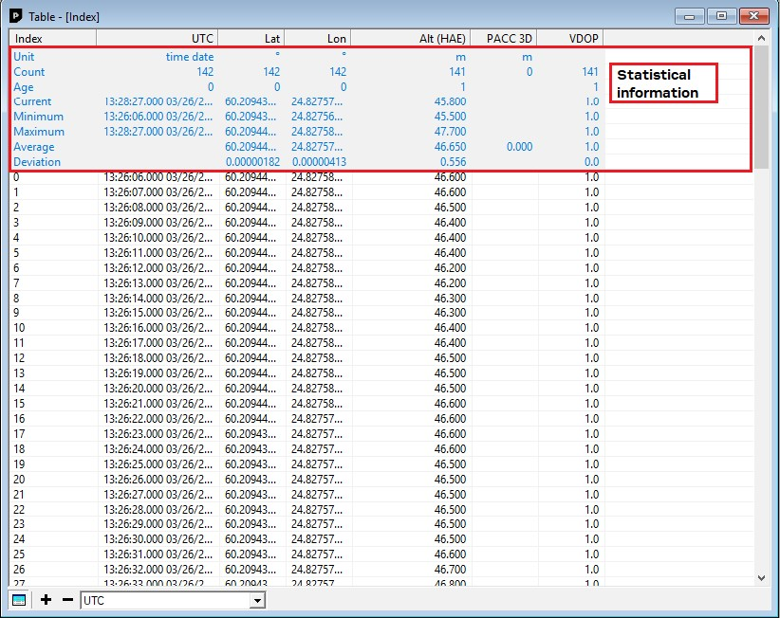

**Figure 32: Table view**

All values from the database can be displayed in a tabular form (Figure 32). This is very useful when analyzing the log file in detail.

To add a new column, first select the desired value (Figure 33) and click the  button. To remove a

displayed value, click the



button. To see the table header click the



button. Statistical information

will be shown for 4 seconds.

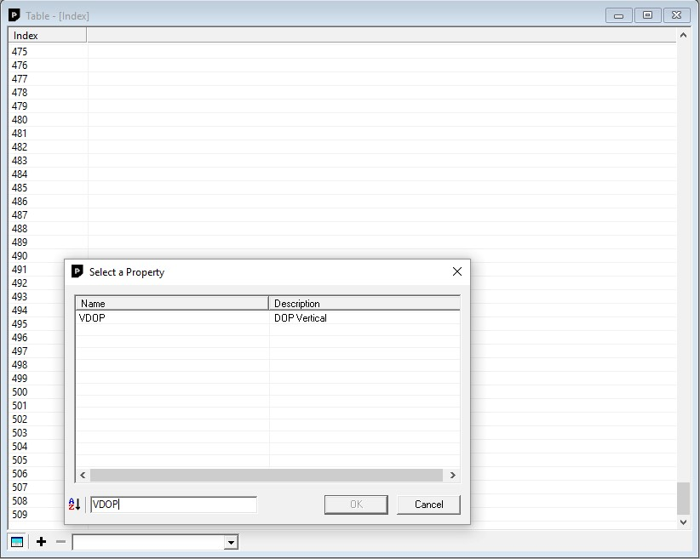

**Figure 33: Selecting a new value**

The number of displayed epochs is set to 1800 by default.

Choosing "Database Empty" in the file menu or pressing the button



clears the table view.

The content of the table view can easily be exported to other programs using Copy/Paste.

#### 5.2.10 Map view

u-center can display positions on pre-calibrated or Google online (dynamic) maps (see Figure 34).

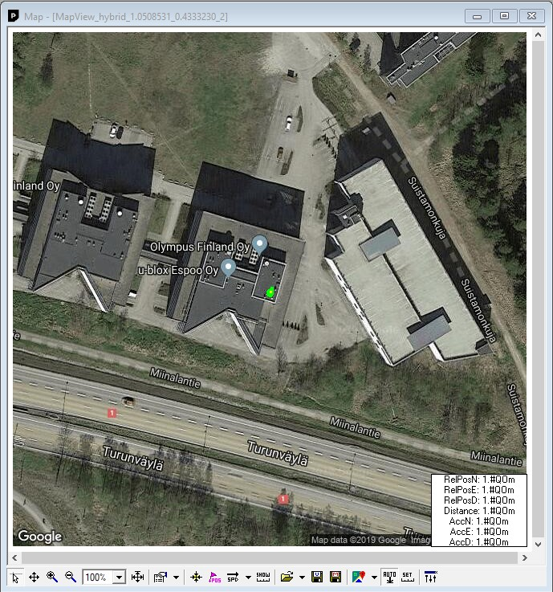

**Figure 34: Map view with Google online map**

##### 5.2.10.1 Using map view

If you want to use the Google online maps you have to enter an API key in Tools > Preferences > Access Tokens. A missing API key can lead to the output shown in Figure 35.

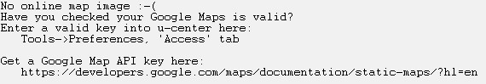

**Figure 35: Missing online map API key**

Please go to

https://developers.google.com/maps/documentation/static-maps/?hl=e

[n](https://developers.google.com/maps/documentation/static-maps/?hl=en)

to

get a valid Google Static Maps API key.

You can access the view specific commands in two different ways:

* Using the command in the tool bar below the map view.
* Holding the cursor inside the map view and pressing the right mouse button. This will open the following context menu (see Figure 36).

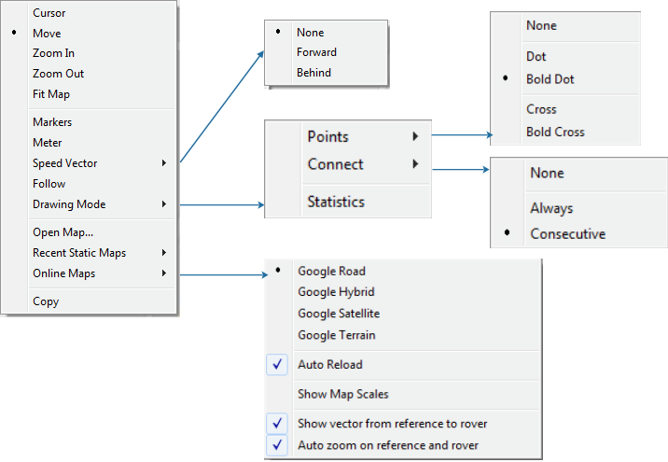

**Figure 36: Map view context menu**

|  |  |  |  |
| --- | --- | --- | --- |
| **Function** | **Description** | **Shortcut /**  **Toolbar icon** | |
| **Cursor** | The position of the cursor is shown on the lower left edge of the u-center screen (Longitude, Latitude and Pixel-Position). By holding the left mouse button and moving the cursor over the map you can measure distance from one position to another. |  | |
| **Move** | The map inside the map view window can be moved. |  | |
| **Zoom In** | The map is enlarged by selecting a rectangle. |  | |
| **Zoom Out** | The size of the map is decreased. |  | |
| **Zoom** | Zoom the map to a specified level. |  | |
| **Function** | **Description** | **Shortcut /**  **Toolbar icon** | |
| **Fit Map** | The map size is adjusted to fit the Map Window. |  |  |
| **Markers** | Add or remove the defined markers (see also section Map calibration) |  |  |
| **Meter** | Show or hide the ruler. |  |  |
| **Speedvector** | Show or hide the speed vectors, and select where they are drawn from. |  |  |
| **Follow** | Centers the map on the current GNSS position. |  |  |
| **Drawing Mode** | The size and form of the displayed position can be changed in the menu **Points**; the connection line between the points can be selected in the menu **Connect**. To see statistical values (average, minimum, maximum, standard deviation) directly in the map, select the menu entry Statistic. |  |  |
| **Open Map... / Recent Static Maps** | Open a new or one of 8 recently used static maps. |  |  |
| **Online Maps** | Use online maps. Select the type in the menu and also if they should be automatically downloaded when the current position moves out of the current map tile (**Auto Reload**). The menu option **Show Map Scales** allows you to select a different scale of the tiles. The menu option **Show vector from reference to rover** will show the vector pointing from reference to rover if such configuration exists. In this case, auto zoom capability exists to track the two by selecting the option **Auto zoom on reference and rover.** | / | / |
| **Save map (only in toolbar)** | Save the current map view to a file (combined with all visible elements or only the map). |  | / |
| **Image settings (only in toolbar)** | Brightness, contrast and color saturation of map can be adjusted by moving the glides. |  |  |

**Table 17: Description of the buttons and context menu entries in map view**

Map Views can be copied to the clipboard using the "Print Screen" function.

Choosing "Database Empty" in the file menu or pressing the button  clears the statistic view.

##### 5.2.10.2 Map calibration

To create your own map you will need a digitized map or picture with orthogonal projection in one of the following pixel graphics formats.

**png** Portable Network Graphics **bmp** Windows Bitmap **dib** Device Independent Bitmap **gif** Graphics Interchange Format **jpg/jpeg** Jpeg File Interchange Format

**pcx** PC Paintbrush **tif** Tag Image File Format

If your map is not in one of the above formats, you can simply convert it in one of the supported formats by a third party program.

To use a map in u-center, three calibration points are needed. For these points you have to know the pixel coordinates and the according WGS84 coordinates in the latitude/longitude format in degrees (longitude: -180.0° to 180.0°, latitude: -90.0° to 90.0°). These points are stored in the map calibration file. The calibration file must be stored at the same location as the bitmap itself. It has the same name but a different extension (*.mcf). The format of the calibration file is very simple and can be edited in a simple editor like notepad.

###### 5.2.10.2.1 Example

As an example we will have a look at the virtual map file world.png and its calibration file world.mcf.

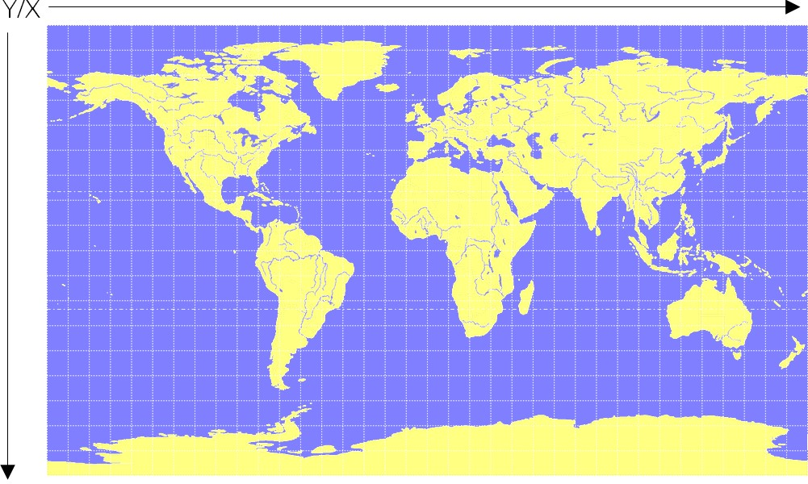

**Figure 37: Digital map file: world.png**

The Map has 1765 pixels (0 to 1764) in the horizontal and 1046 pixels (0 to 1045) in the vertical direction. The origin is the upper left corner. To calibrate this map we will use the following three calibration points (#1 to #3).

|  |  |  |  |  |
| --- | --- | --- | --- | --- |
|  |  | **Pixel** |  | **WGS84**  **Coordinate** |
| **Reference Point** | **#** | **X** | **Y** | **Longitude Latitude** |
| Upper Left Corner | 1 | 0 | 0 | -180.0 90.0 |
| Lower Right Corner | 2 | 1764 | 1045 | 180.0 -90.0 |
| Upper Right Corner | 3 | 1764 | 0 | 180.0 90.0 |

**Table 18: Calibration reference points**

To determine the exact pixel position you can use Microsoft Paint (mspaint.exe) or any other pixelediting program.

The calibration file is a plain ASCII text file. The file may contain comments. The file consists of two sections, which start with keywords encapsulated in braces.

The REFERENCE section, which is mandatory, contains the three points used to calibrate a map. Each reference point is on a single line and has the following syntax: # = <x>, <y>, <lon>, <lat> where

* # is the index of the reference point
* <x> is the horizontal image coordinate
* <y> is the vertical image coordinate
* <lat> is the latitude in degrees and WGS84
* <lon> is the longitude in degrees and WGS84.

The optional MARKER section defines additional points on the map. Each point is on a single line with the syntax: # = i, <x>, <y>[, <text>] or # = c, <lat>, <lon>[, <text>] where

* # is the index of the marker point
* i indicates that the coordinates relate to the image
* c indicates that the coordinates relate to the world
* <x> is the horizontal image coordinate
* <y> is the vertical image coordinate
* <lat> is the latitude in degrees and WGS84
* <lon> is the longitude in degrees and WGS84.
* <text> is a optional string in quotes labeling the marker point.

The points must have a unique index from 1 to <num>. The maximum marker point index <num> is written to the same section on a separate line with the syntax Count = <num>.

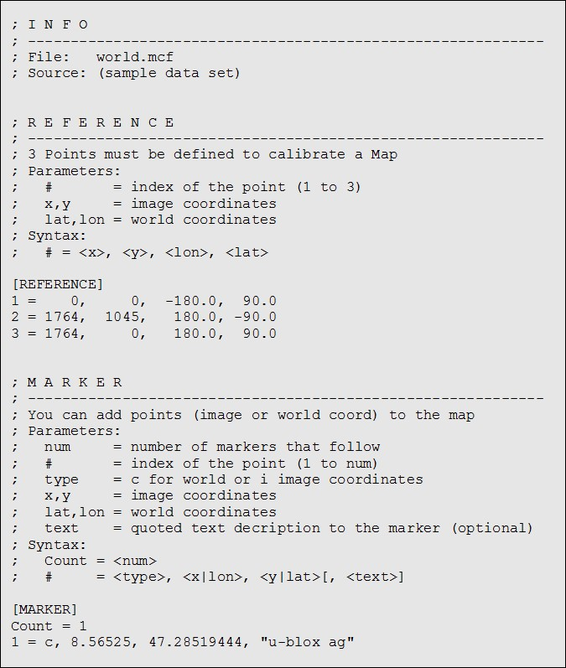

**Figure 38: Map calibration file: world.mcf**

**5.2.10.2.2 Map calibration tool** u-center includes a built-in calibration tool for providing coordinates to maps and photographs in supported data formats to create u-center maps. To use the tool open the map view window as seen in Figure 39 and then open the file of the map to be calibrated.

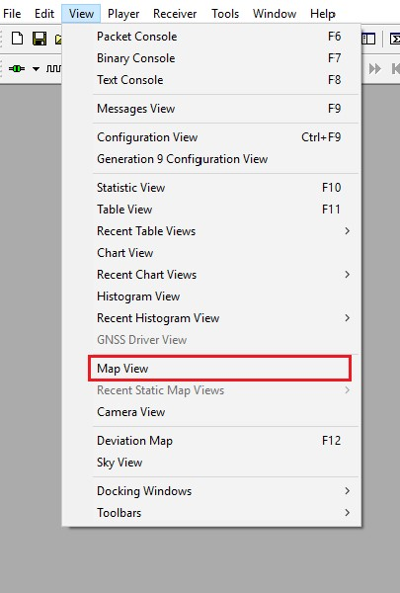

**Figure 39: Opening map view window**

If the file to be opened has not been calibrated, the message in Figure 40 will appear.

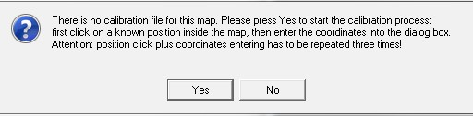

**Figure 40: No calibration information found**

Select three points on the map and enter the calibration coordinates in the specified format as seen in Figure 41.

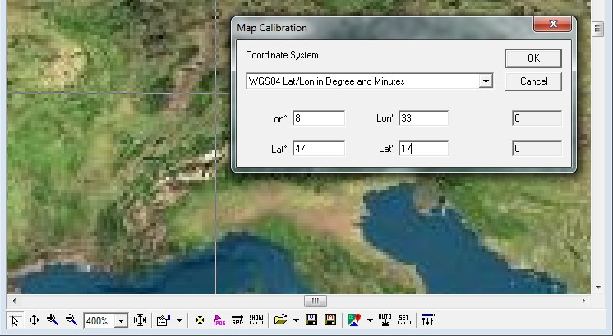

**Figure 41: Calibrating a map using calibration tool**

Following these steps the map is now calibrated and can be used with u-center.

#### 5.2.11 Chart view

Chart view allows you to conveniently view GNSS data records in graphical form. The data can be scaled in many different ways and formats. It's even possible to print the entire chart. The examples below illustrate two different typical applications.

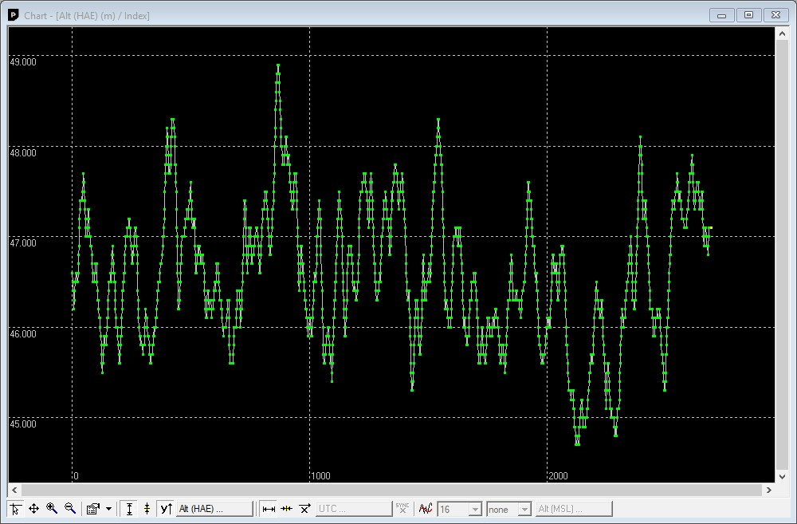

**Figure 42: Altitude as a function of Index (X = Index, Y = Alt)** The position of the cursor is shown on the lower left edge of the u-center screen (Longitude, Latitude and Pixel-Position). By holding the left mouse button and moving the cursor over the chart you can measure distance from one position to another.

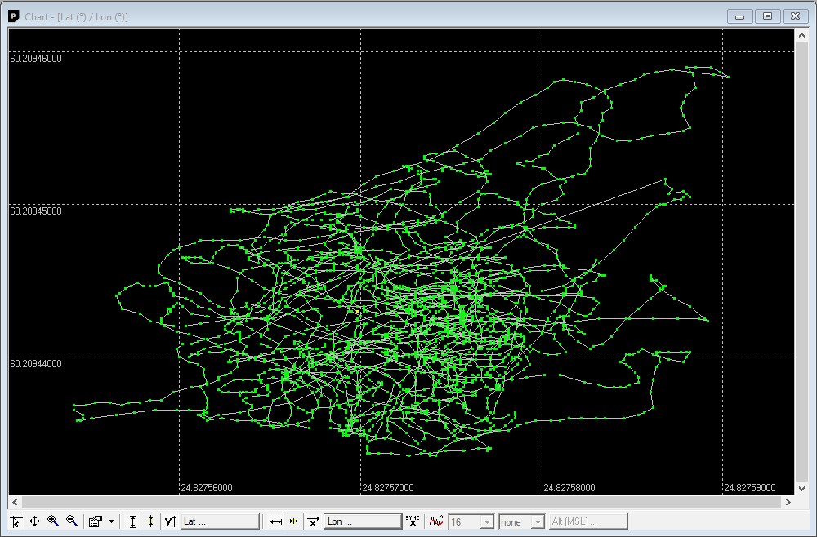

**Figure 43: Latitude as a function of longitude (X =Longitude, Y = Latitude)**

**Function**

**Description**

**Shortcut /**

**Toolbar icon**

**Cursor**



|  |  |  |  |  |  |  |  |  |  |  |  |  |  |  |  |  |  |  |  |  |  |  |  |  |  |
| --- | --- | --- | --- | --- | --- | --- | --- | --- | --- | --- | --- | --- | --- | --- | --- | --- | --- | --- | --- | --- | --- | --- | --- | --- | --- |
| |  |  | | --- | --- | | **Move** | The chart inside the chart view window can be moved. | | **Zoom In** | Drawing a rectangle enlarges the chart to the new view. To zoom in the chart double-click on the chart. | | **Zoom Out** | Drawing a rectangle decreases the chart to the new view. To zoom out the chart double-click on the chart. | | **Drawing Mode** | The size and form of the displayed values can be changed in the menu points; the connection line between the values can be selected in the menu connect. For viewing the statically values (average, minimum, maximum, standard deviation) directly in the chart select the statistics menu. | | **Fit Y range** | Fits the Y range. | | **Follow Y** | Follow the most current Y value (the most current Y-value is always in the middle of the chart). | | **Index or Y value** | Switch between the index and the Y value. | | **Y value** | Select the Y value to be displayed. | | **Fit X range** | Fit the X range. | | **Follow X** | Follow the most current X value (the most current X value is always in the middle of the chart). | | **Index or X value** | Switch between the index and the X value. | | **X value** | Select the X value to be displayed. | |  |
|  |
|  |
|  |
|  |
|  |
|  |
|  |
|  |
|  |
|  |
|  |

**Function**

**Description**

**Shortcut /**

**Toolbar icon**

**Moving average**

Adds a moving average. The average is calculated over the number of most recent

values, specified with the parameter.

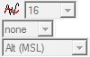

**Table 19: Description of the buttons in the chart view toolbar**

The number of displayed epochs is set to 1800 by default.

#### 5.2.12 Histogram view

Histogram views allow you to view GNSS data and probability distributions (see Figure 44) and print the entire histogram if desired. The number of bins (storage containers) can be set by you.

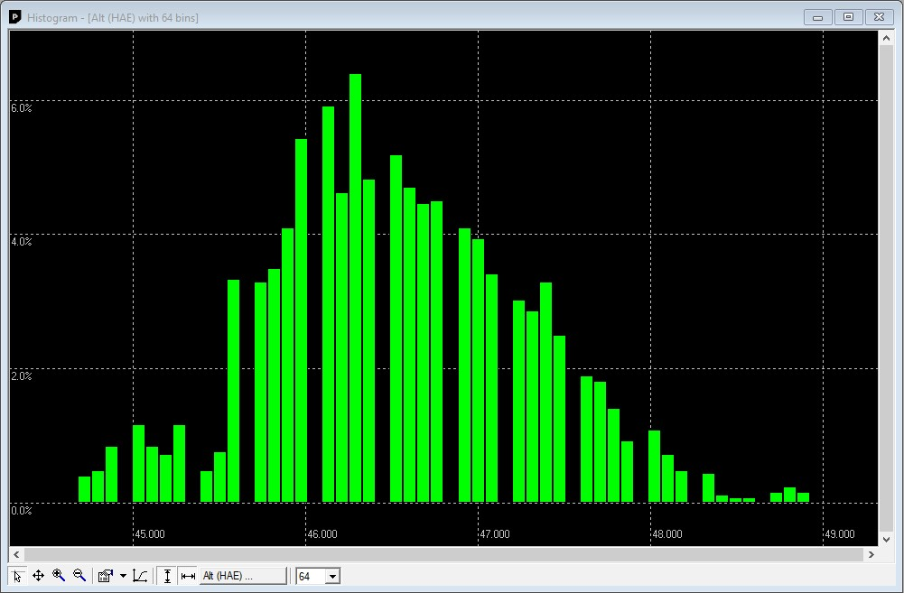

**Figure 44: Altitude Histogram View**

The position of the cursor is shown on the lower left edge of the u-center screen (Longitude, Latitude and Pixel-Position). By holding the left mouse button and moving the cursor over the histogram you can measure distance from one position to another.

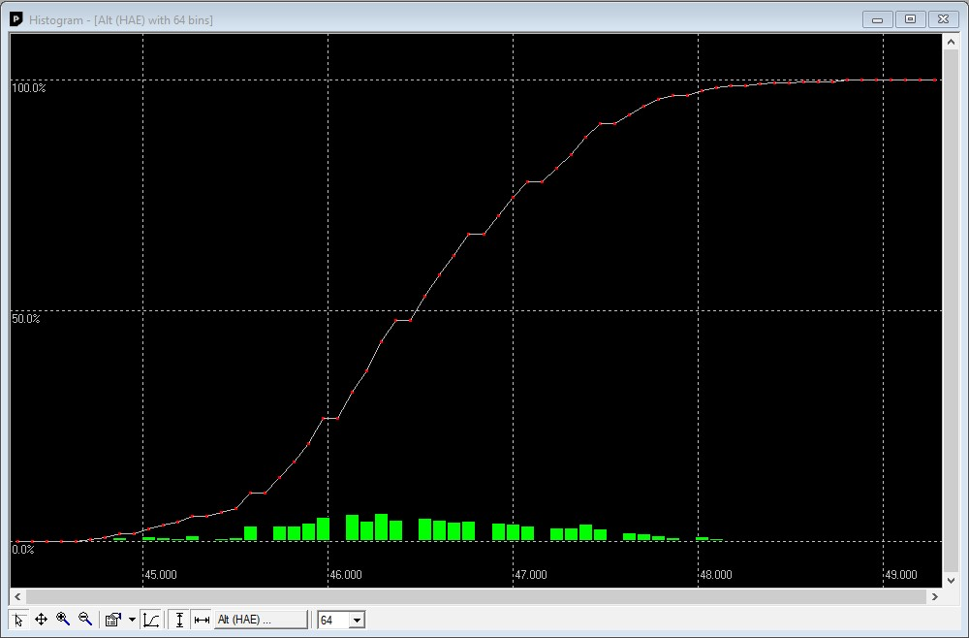

**Figure 45: Probability chart**

**Function**

**Description**

**Shortcut /**

**Toolbar icon**

**Cursor**



|  |  |  |  |  |  |  |  |  |  |
| --- | --- | --- | --- | --- | --- | --- | --- | --- | --- |
| |  |  | | --- | --- | | **Move** | The histogram inside the histogram view window can be moved. | | **Zoom In** | Drawing a rectangle enlarges the histogram to the new view. To zoom in the histogram double-click on the histogram. | | **Zoom Out** | Drawing a rectangle decreases the histogram to the new view. To zoom out the histogram double-click on the histogram. | | **Drawing Mode** | The size and form of the displayed values can be changed in the menu points; the connection line between the values can be selected in the menu connect. For viewing the statically values (average, minimum, maximum, standard deviation) directly in the histogram select the statistics menu. | |  |
|  |
|  |
|  |

**Probability**

Fit the Probability range.



**Fit Probability**

Fit the Probability range



**Y value**

Select the Y value to be displayed.



**Bins**

The number of bins.



**Table 20: Description of the buttons in the histogram view toolbar**

The number of displayed epochs is set to 1800 by default.

#### 5.2.13 Camera view

The camera view function enables photographs, taken during recording of log files, to be linked to the GNSS data stored in the corresponding log files. This allows a video depiction of the test, with a picture assigned to a specific point of GNSS data.

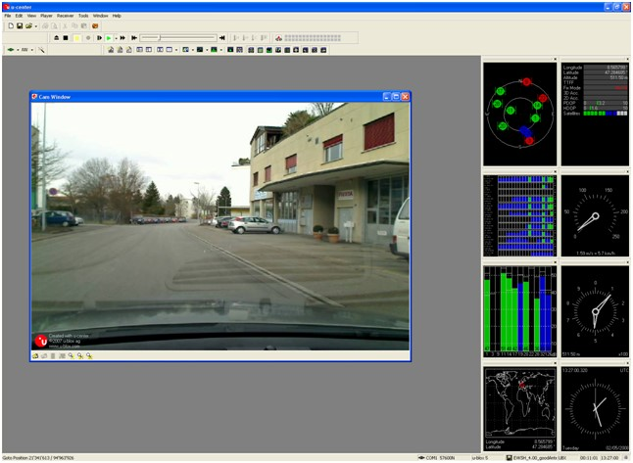

**Figure 46: Camera view**

Using Camera View can result in very large log files and can slow down u-center when

playing such files.

#### 5.2.14 Deviation map

The deviation map displays positions in longitude and latitude relative to a defined reference position.

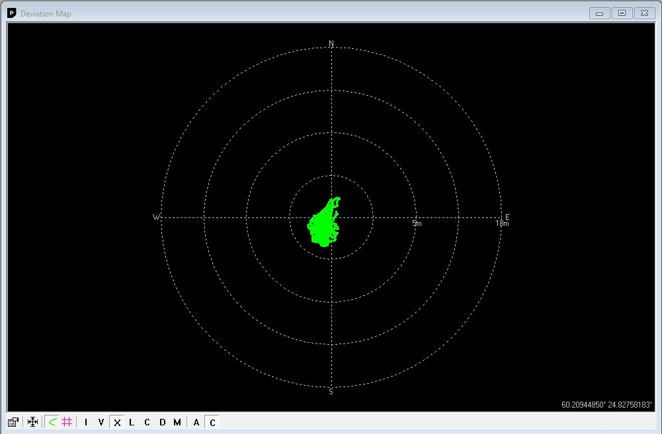

**Figure 47: Deviation map**

**Function**

**Description**

**Shortcut /**

**Toolbar icon**

**Properties**

The reference position can be defined as:



* The average of all previously measured positions
* The current position
* A fixed, predefined value
* The radius of the outer circle can be adjusted with the Max. Deviation parameter.

|  |  |  |  |  |  |  |  |  |  |  |  |
| --- | --- | --- | --- | --- | --- | --- | --- | --- | --- | --- | --- |
| |  |  | | --- | --- | | **Fit** | Automatically adjusts the reference position and the maximum deviation to fit all positions into the deviation map. | | **Track** | Show track of values from the internal database. | | **Statistics** | Show statistics of the values from the internal database. | | **Maximum deviation shortcut** | Shortcut for changing the scale of the deviation map to prefixed values. The icons represent Roman numerals, with "I" corresponding to a 1 m radius of the deviation map, and "V"= 5 m, "X"= 10 m, "L"= 50 m, "C" = 100 m, "D" = 500 m, and "M" = 1000 m. | | **Reference position shortcut** | Shortcut for setting the reference position:   * A = average position * C = current position | |  |
|  |
|  |
|  |
|  |

**Table 21: Description of the buttons in the deviation map toolbar**

The number of displayed epochs is set to 1800 by default.

You can use the mouse scroll wheel to zoom in/out on the deviation map. Holding down the Shift key allows you to zoom in beyond the default 1 m maximum zoom.

#### 5.2.15 Sky view

Sky view is an excellent tool for analyzing the performance of antennas as well as the conditions of the satellite observation environment. The polar plot graphically displays the averaged relative satellite signal strength (see Figure 48), the position of satellites in the sky, identifies satellites by number and indicates which satellites are being used in the receiver calculation. Right-clicking the mouse on sky view allows the copying of C/N0 values in tabular form to another program.

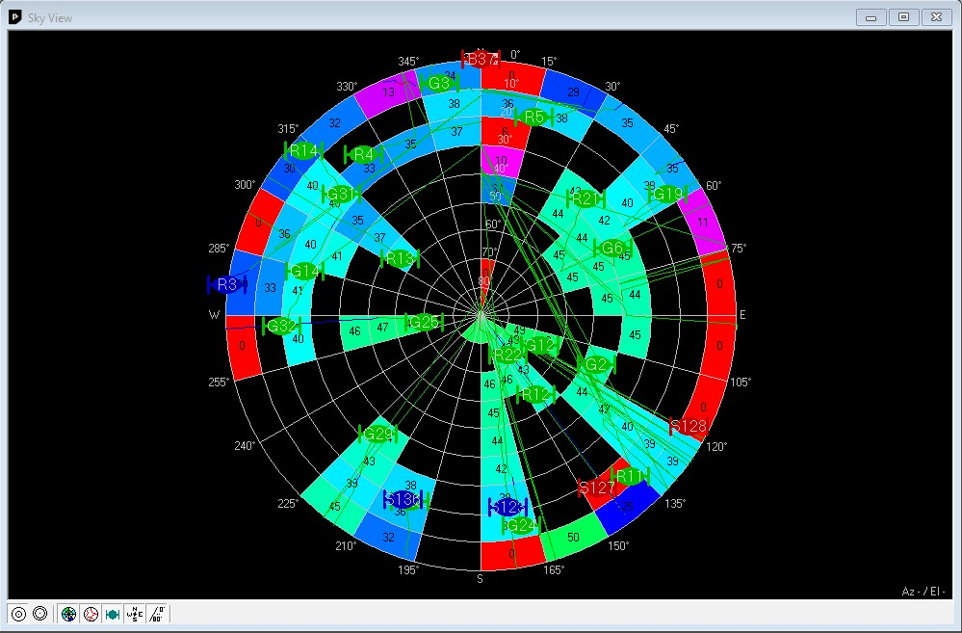

**Figure 48: Sky view**

**Function**

**Description**

**Shortcut /**

**Toolbar icon**

**Linear projection**

Displays the sky view with a linear projection.



**Sine projection**

Displays the sky view with a sine projection.



**C/N0**

Displays or hides the averaged C/N0 values.



**Orbits**

Displays or hides the satellite orbits.



**Satellites**

Displays or hides the current satellite positions.



**Coordinates**

Displays or hides the caption for the azimuth.



**Elevation**

Displays or hides the caption for the elevation.



**Table 22: Description of the buttons in the sky view toolbar**

1. **NTRIP**

This section will give an overview of the NTRIP support in u-center. Currently u-center supports both NTRIP client and NTRIP caster/server functionality. Settings for both of them can be found under "Receiver" menu.

Networked Transport of RTCM via Internet Protocol (NTRIP) is an application-level protocol that supports the streaming of Global Navigation Satellite System (GNSS) data over the Internet. NTRIP is a generic, stateless protocol based on the Hypertext Transfer Protocol HTTP/1.0. The HTTP objects are extended to GNSS data streams.

**6.1 NTRIP client**

NTRIP client allows connecting to any NTRIP compliant caster and receiving RTCM correction data for receiver. Currently version 1 of NTRIP standard is implemented.

Perform the following steps to connect to the caster (steps 10 to 14 are only needed when the mount point requires additional NMEA message to be sent by the client):

1. Establish the communication between u-center and the device (see also Connect to the receiver).
2. Open NTRIP client settings dialog by clicking on Receiver > NTRIP Client...

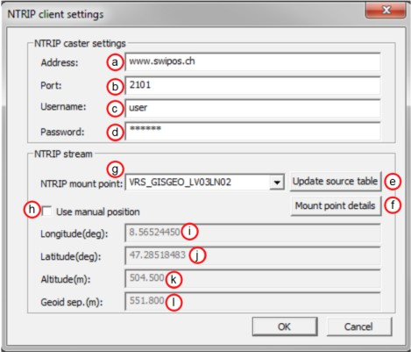

**Figure 49: NTRIP client settings dialog**

1. Enter the address of the NTRIP caster. See position **a**.
2. Enter the port number of the NTRIP caster. See position **b**.
3. Enter the username which will be sent to the NTRIP caster. If no authentication is required by the caster, then leave this field empty. See position **c**.
4. Enter the password which will be sent to the NTRIP caster. If no authentication is required by the caster, then leave this field empty. See position **d**.
5. Click on **Update source table** to get an up to date list of all available mount points from the caster. See position **e**.
6. To see the detailed attributes of mount points, click on **Mount point details**. This will bring up a new dialog box listing all the mount points available and their attributes. See position **f**.
7. Select one of the mount points listed in the drop down box. See position **g**.
8. Click on **Use manual position** to enter values for position data. If this is not checked, the position data will be retrieved directly from the receiver. See position **h**.
9. Enter the longitude in degrees, in either floating point or integer format. See position **i**.
10. Enter the latitude in degrees, in either floating point or integer format. See position **j**.
11. Enter the altitude in meters in floating point or integer format. See position **k**.
12. Enter the geoid separation in meters in floating point or integer format. See position **l**.
13. Click on **OK** to start receiving correction data.

**6.2 NTRIP server/caster**

The u-center NTRIP caster is able to accept requests from NTRIP compliant clients and send them RTCM correction data. This is implemented according to NTRIP standard version 1. The server part is not implemented according to the standard but we are currently supporting one mount point, which gets data from direct connection to the receiver.

Perform the following steps to set up the caster:

1. Establish communication between u-center and the device (see also Connect to the receiver).
2. Open NTRIP server/caster settings dialog by clicking on Receiver > NTRIP Server/Caster... There are two tabs. First tab contains the basic configuration (port only), while the second tab contains the rest of the configuration options.

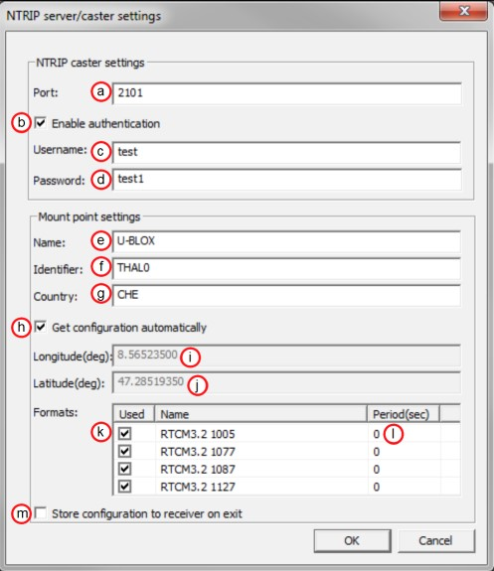

**Figure 50: NTRIP server settings dialog, both the Basic and More tabs**

1. Enter the port that will be used by the NTRIP caster. See position **a**.
2. Check "Enable authentication" if you want to enable basic authentication on your caster. See position **b**.
3. Enter the username which will have to be provided by the clients (only if you enabled authentication under 4). See position **c**.
4. Enter the password which will have to be provided by the clients (only if you enabled authentication under 4). See position **d**.
5. Enter the name for the mount point. See position **e**.
6. Enter the identifier for the mount point e.g. name of the city next to mount point location. See position **f**.
7. Enter the country code in ISO 3166 for the mount point. See position **g**.
8. Check **Get configuration automatically** to use longitude, latitude and RTCM message configuration of the currently connected receiver that will be sent out on the mount point. In this case, you can go directly to 16. See position **h**.
9. Enter the longitude for the mount point in integer or floating point format. See position **i**.
10. Enter the latitude for the mount point in integer or floating point format. See position **j**.
11. Select the RTCM messages that will be sent by the mount point. See position **k**.
12. For every selected RTCM message enter the period at which messages will be sent to the clients. See position **l**.
13. Check **Store configuration to receiver on exit** to store the configuration of RTCM messages to the receiver (using the UBX-CFG-MSG message). See position **m**.
14. Click **OK** to start NTRIP server/caster.

**7 Google Earth server**

This section gives an overview of the Google Earth server support in u-center.

The Google Earth server can continuously send positioning data in a specific format to the Google Earth application. By hosting such a server in u-center we are able to visualize positioning data in real time.

There are only a few settings that can be set via the Google Earth server dialog. This means a lot of functionality and behavior of the Google Earth is still configurable from the application itself and therefore out of control of u-center's direct control.

Perform the following steps to start the Google Earth server:

1. Establish the communication between u-center and the device (see also Connect to the receiver).
2. Open Google Earth settings dialog by clicking on File > Database Export > Google Earth Server...

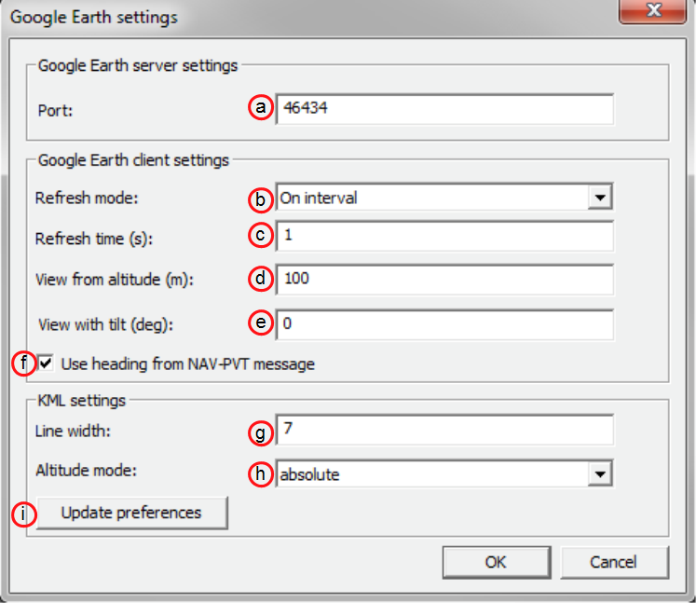

**Figure 51: Google Earth settings dialog**

1. Enter the port of the server. See position **a**.
2. Select the refresh mode. Supported modes are "On camera stop" where Google Earth will send requests only when previous view has stabilized or "On interval" where requests from Google Earth will be sent in regular intervals. See position **b**.
3. Enter the refresh time. This is the time between two consecutive requests in "On interval" mode or delay after camera stops in "On camera stop" mode. See position **c**.
4. Enter the altitude in meters of the view. See position **d**.
5. Enter the tilt in degrees of the view. A value of 0 indicates that the view is aimed straight down toward the earth and a value of 90 indicates that the view is aimed toward the horizon. See position **e**.
6. Check this field if you want the heading of the camera to follow heading information coming from UBX-NAV-PVT message. See position **f**.
7. Enter the number to set the line width in the view. Higher values mean a thicker tracking line.

See position **g**.

7 Google Earth server

1. Select the altitude mode for the view. The "absolute" mode sets the altitude relative to sea level, "relativeToGround" mode sets it relative to the actual ground elevation in a particular location and "clampToGround" ignores the altitude specification. See position **h**.
2. Click on **Update preferences** if you want to permanently store information about Line width and Altitude mode. The same can be achieved through menu "Tools > Preferences > KML settings". See position **i**.
3. Click on **OK** to start the server.
   * 1. Google Earth server
     2. **Tools**

This section will give an overview of the embedded tools of u-center. They can be used for different purpose and should facilitate the usage of u-blox GNSS receivers. The tools can be found under the "Tools" menu but some of the options are only displayed when a receiver is connected to u-center. The firmware update tools also depend on the connected receiver generation.

**8.1 Firmware update**

This tool allows you to update the firmware of a receiver. For the firmware update to work, the receiver must have a flash memory attached as the new firmware will be stored in this location.

In the earlier versions of u-center, firmware update was implemented as part of the u-center application. Now, the firmware update is implemented as a separate application which u-center launches and passes parameters to, depending on the options selected in the UI.

To update the firmware, perform the following steps:

1. Display the firmware update tool view by clicking on Tools > Firmware Update...

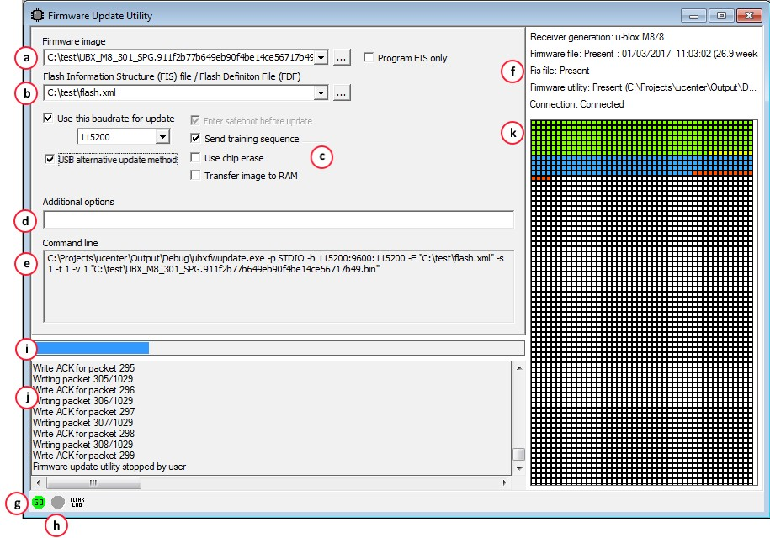

**Figure 52: Firmware update view**

1. Select the firmware image suitable for the connected receiver. See position **a** on Figure 52.
2. Select the flash information structure file (only needed if using u-blox receiver generation 7 or later), or the flash definition file (only needed before u-blox receiver generation 7). These files should be bundled with u-center. See position **b** on Figure 52.
3. Select the options for your receiver. See position **c** on Figure 52.

|  |  |  |
| --- | --- | --- |
| **Option** | **Description** | **Recommended** |
| Use this Baud rate for update | Selects the speed of the communication for updating the firmware on the receiver. Only has an effect when the receiver is connected over a serial port. | 115200 |
| Program FIS only | Writes only the flash information structure (FIS) into the external memory and does not update the firmware. This option is used for receivers running from ROM but with an attached SQI memory (for example for logging). Only supported after and including u-blox receiver generation 7. | disabled |
| Enter Safeboot before update | Sends the command to enter safeboot. In this state, the receiver boots from the internal ring oscillator and does not rely on any external components. GNSS functionality is not started and the receiver does not output any data. Don't use this method when having the receiver connected over USB. | disabled |
| USB alternative update method | Enables updating the receiver via USB. "Enter Safeboot before update" will be disabled automatically if that option has been chosen. | enabled (using  USB only) |
| Send Training sequence | Sends the training sequence after safeboot was entered. This synchronizes the internal ring oscillator so that a communication can be established. | enabled |
| Use chip erase | Erases the flash using an single command instead of individual sector erases. | check support |
| Transfer image to RAM | Transfers the firmware image directly to the receiver's RAM. Not stored to flash. | disabled |

1. The additional options field allows more command options to be specified than are presented in the UI. This feature should only be needed if the firmware update utility launched by u-center has additional features which the development of th UI has not caught up with yet. See position **d** on Figure 52.
2. The command line field displays the actual command line and parameters used to launch the firmware update utility from u-center. This can be used to help diagnose any issues that may occur when performing a firmware update. See position **e** on Figure 52.
3. The status fields display information about the connected receiver, the presence of the firmware and FIS files, and if the firmware update utility can be found. See position **f** on Figure 52. If there is a problem with any of these items, the **Go** button, which starts the update process, will be greyed out.
4. Press the **Go** button to start the firmware update process. This button will only be enabled if ucenter can see the receiver and can find the specified files. If this button is greyed out, check the status display to see what is wrong. See position **g** on Figure 52.
5. Press the **Stop** button to terminate the firmware update process. This will only be enabled when the update process is running. See position **h** on Figure 52.
6. During firmware update, a progress bar is displayed. See position **i** on Figure 52.
7. A log is also displayed during the update process. See position **j** on Figure 52.
8. A detailed image of the flash erase and writing progress will also be shown. See position **k** on Figure 52.

**8.2 Legacy Firmware update u-blox 5 - 8**

This is the legacy receiver firmware update tool, which is built into the u-center binary. It can be used to program u-blox 5 to u-blox 8 receivers. Further feature development has been stopped and u-center now uses the stand alone command line firmware update utility as the primary firmware update mechanism. This is documented in the previous section. In the future, this legacy firmware update tool will be removed permanently from u-center.

As with the primary firmware update tool, the receiver has to have a flash memory attached as the firmware has to be stored in this location.

Perform the following steps to update the firmware:

1. Establish the communication between u-center and the device (see also Connect to the receiver).
2. Open firmware update tool by clicking Tools > Legacy Firmware Update...

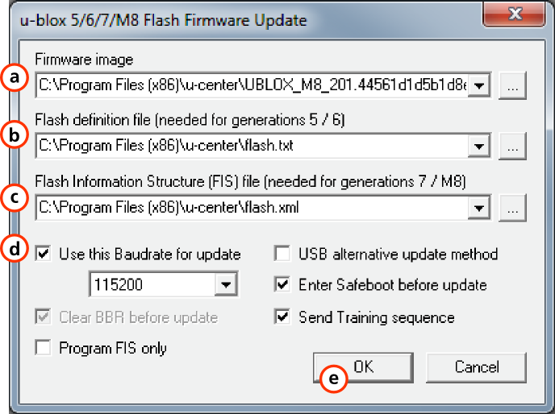

**Figure 53: Legacy firmware update window**

1. Select the firmware image suitable for the connected receiver. See position **a** on Figure 53.
2. Select the flash definition file (only needed before u-blox receiver generation 7). This file is bundled with u-center. Point to the latest file version. See position **b** on Figure 53.
3. Select the flash information structure file (when using u-blox receiver generation 7 or later). This file is also bundled with u-center. Point to the latest file version. See position **c** on Figure 53.
4. Select the correct options for your receiver. See position **d** on Figure 53.

|  |  |  |
| --- | --- | --- |
| **Option** | **Description** | **Recommended** |
| Use this Baud rate for update | Selects the speed of the communication for updating the firmware on the receiver. Only has an effect when the receiver is connected over a serial port. | 115200 |
| Clear BBR before update | Deletes the complete battery backed memory (BBR) so that the receiver will start with the default configuration. | enabled |
| Program FIS only | Writes only the flash information structure (FIS) into the external memory and does not update the firmware. This option is used for receivers running from ROM but with an attached SQI memory (for example for logging). Only supported after and including u-blox receiver generation 7. | disabled |
| **Option** | **Description Recommended** | |
| USB alternative update method | Erases the first sector of the flash memory and restarts the receiver. The receiver will then start from ROM and the flash firmware can be updated. Use this method if you want to update the firmware of a receiver connected over USB. | disabled |
| Enter Safeboot before update | Sends the command to enter safeboot. In this state, the receiver boots from the internal ring oscillator and does not rely on any external components. GNSS functionality is not started and the receiver does not output any data. Don't use this method when having the receiver connected over USB. | enabled |
| Send Training sequence | Sends the training sequence after safeboot was entered. This synchronizes the internal ring oscillator so that a communication can be established. | enabled |

1. Click **OK**.
   1. **Dump receiver diagnostics**

This tool is used to dump the receiver diagnostic to a file. Use this tool if requested by the support team.

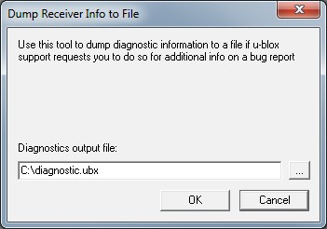

**Figure 54: Dump receiver diagnostics tool**

* 1. **GNSS configuration**

u-center is capable of getting the actual configuration of a u-blox GNSS positioning chip or module and storing it to an ASCII text file containing hexadecimal records. Such a file can be edited and stored to a u-blox GNSS device again. In u-center Tools menu, select GNSS Configuration to open the GNSS Configuration dialog box. The following functions are available:

* Specify the name of a new configuration file to store current configuration from the u-blox GNSS device
* Specify the name of an existing configuration file and load this configuration into the u-blox GNSS device
* A flag can be set to force storing the configuration into a Battery Backed RAM (BBR) or Flash, applicable for u-blox 5 to u-blox 8/M8 only.

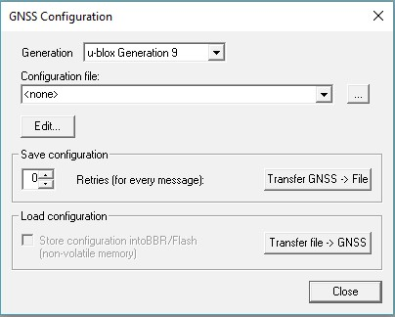

**Figure 55: GNSS configuration tool**

#### 8.4.1 Read/Write configuration files

1. Connect to the device.
2. Open "Tools > GNSS Configuration".
3. Select the u-blox receiver generation connected from the **Generation** drop down menu.
4. To read an existing configuration file, select the name of the file, then click **Transfer file > GNSS** button. The GNSS Configuration window then closes and the progress window pops up, showing the configuration being sent to the receiver. This progress window closes after successful transfer.
5. To write a new configuration file, click " Transfer GNSS > File". The GNSS Configuration window closes and the progress window pops up, showing the configurations being polled and stored into a local file in ASCII format.

Select **Store configuration into BBR/Flash** checkbox if the parameters need to be stored into the device's non-volatile memory (BBR/Flash). This option is applicable for u-blox 5 to ublox 8/M8 generation receivers.

Sending a configuration to a u-blox GNSS device may fail due to a baud rate change on the current serial port of the receiver to which the configuration is being sent. If this happens, simply change the u-center baud rate and send the configuration again.

If reading or writing configuration data fails too frequently, try to increase the number of retries ucenter should do on a single message if one fails.

The user can abort the transfer by clicking the **Abort** button. It is not possible to close the window unless the transfer is complete or aborted by the user.

It is not recommended to read/write configuration while the u-blox GNSS device is in sleep mode.

#### 8.4.2 Editing configuration file

When clicking the **Edit** button in the GNSS Configuration dialog, the Notepad editor opens (standard Windows software). Configurations are stored the following way:

* The first line contains the version of the u-blox GNSS receiver where the configuration is from. **Never change this line!**
* For the second and following lines, each line contains the same: <class ID>-<message ID> <hexadecimal byte code of the message>. The byte code consists of class and message IDs (2 bytes), payload length (2 bytes), payload (payload length bytes). The sync characters and the checksum are not included. They will be calculated automatically.

Refer to *u-blox Receiver Description including Protocol Specification* for detailed information and ranges.

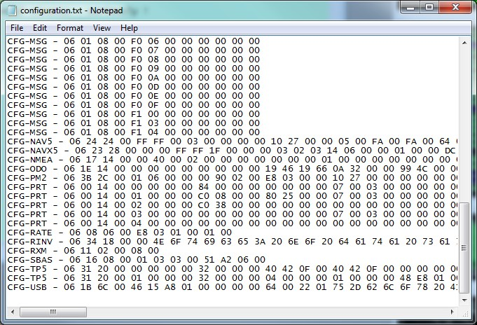

**Figure 56: Content of GNSS configuration file**

**8.5 Preferences**

The preferences tool can be used to configure a number of u-center parameters.

1. **How To**

**9.1 Change baud rate of receiver**

1. Connect to the device.
2. Open View / Messages View (Hotkey: F9).
3. Select UBX-CFG-PRT.
4. Poll the current configuration from the receiver ().
5. Change the setting to the desired baud rate.
6. Send the message to the receiver ().

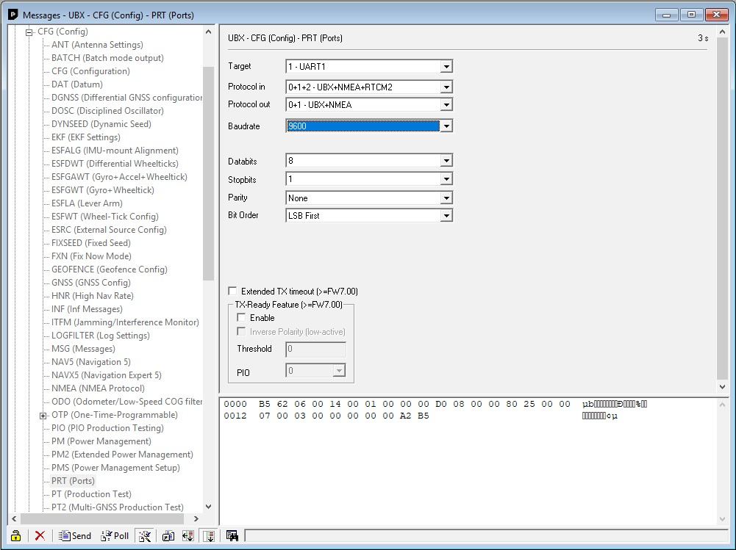

**Figure 57: Changing baud rate (using UBX-CFG-PRT)**

**9.2 Save parameters to receiver non-volatile memory (BBR/ Flash)**

There are 2 ways to save parameters to the receiver's non-volatile memory (BBR/Flash).

#### 9.2.1 Saving parameters with UBX-CFG-CFG

1. Connect to the device.
2. Open View / Messages View (Hotkey: F9).
3. Select UBX-CFG-CFG.
4. Select “save current configuration” (see Figure 58).
5. Send the message to the receiver ().

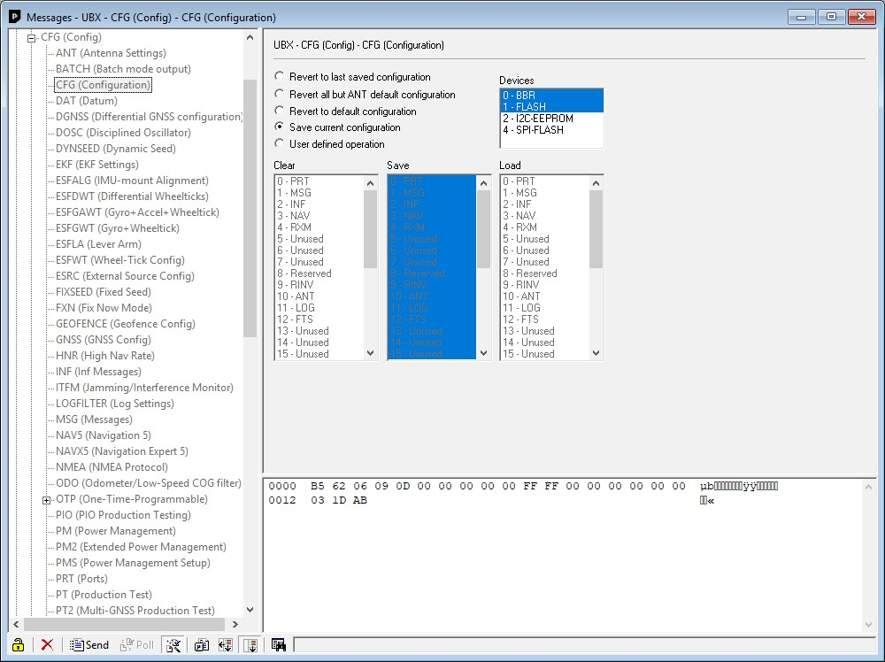

**Figure 58: Saving Parameters (using UBX-CFG-CFG)**

**9.2.2 Saving parameters with GNSS configuration**

Refer to chapter Read/Write configuration files

* 1. **Recording/Playing a log file**

u-center allows recording and playing log files. Use the player controls, to record or playback a log file. Select the log file to be opened through the file menu tool bar. The series of buttons in the player toolbar can be used to navigate through the log file. The records will be displayed on the navigation display window, in the same way that live GNSS data is displayed when using u-center. Refer to Player for a description of the menu items.

* 1. **Conduct sensitivity tests**

u-center is a useful tool for conducting sensitivity tests of GNSS positioning chips and modules and receiver designs. To do so, under open sky conditions record a log file of the receiver to be tested and an Evaluation Kit as reference. Make sure that the log files are recorded under the same conditions.

Using the Statistic View or Table View windows from u-center, compare the C/N0 values of the five strongest satellites. With Table view, export the values to a spreadsheet for analysis.

* 1. **Read/Write configuration files**

Refer to chapter Read/Write configuration files

* 1. **Set GNSS configuration**

1. Connect to the device.
2. Open View / Messages View (Hotkey: F9).
3. Select UBX-CFG-GNSS.
4. Place or remove the checkmark for the desired GNSS under **Enable**.
5. Send the message to the receiver ().

The following figure shows an example that configures the device to receive GPS and GLONASS.

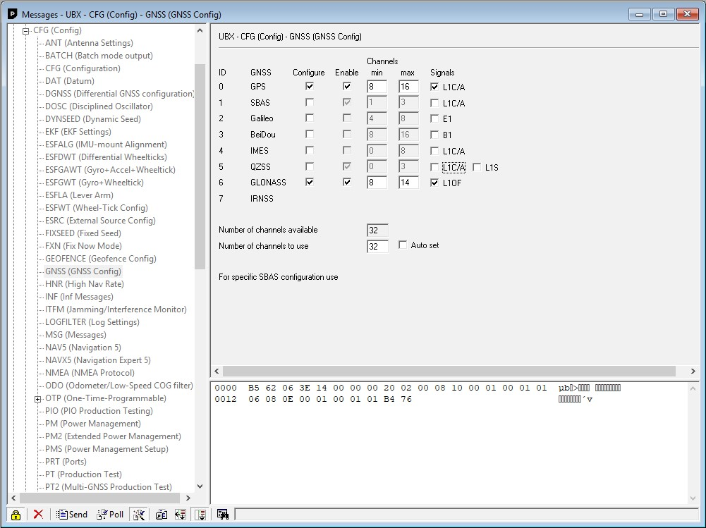

**Figure 59: GNSS configuration (using UBX-CFG-GNSS)**

**9.7 Change epoch detection method**

u-center looks for epochs in the incoming messages from the receiver, and uses them as a heartbeat to trigger view updates and calculate the statistics. To detect new epochs, u-center examines various groups of fields in the incoming message stream. To specify which field groups u-center is interested in for epoch detection, open the dialog under "Receiver > Epoch detection...".

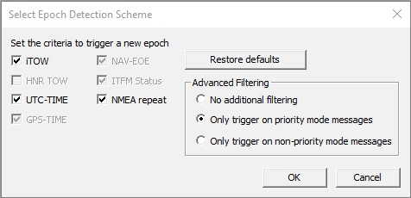

**Figure 60: Select epoch detection method**

From the "Select Epoch detection Scheme" window, the following options can be configured:

|  |  |  |
| --- | --- | --- |
| **Option** | **Description Default** | |
| iTOW | Monitor the "iTOW" database element. Trigger an epoch if a difference is seen. Yes Typically UBX-NAV messages cause this trigger. | |
| HNR TOW | Monitor the "NAV-HNR iTOW" database element. Trigger an epoch if a difference No is seen. HNR based messages cause this trigger. | |
| UTC-TIME | Monitor the "UTC" database element. Trigger an epoch if a difference is seen. Yes Typically NMEA messages cause this trigger. | |
| GPS-TIME | Monitor the "GPS time" database element. Trigger an epoch if a difference is seen. Yes Typically PUBX messages cause this trigger. | |
| NAV-EOE | Monitor for incoming UBX-NAV-EOE messages. Trigger an epoch if one is seen. | Yes |
| ITFM Status | Monitor the "ITFM Status" database element. Trigger an epoch if a difference is seen. The UBX-RXM-INTF message causes this trigger. | Yes |
| NMEA repeat | Monitor for NMEA messages. Trigger an epoch if the same NMEA message is seen twice since the last epoch. Excluding GxGRS and GxGSA. | Yes |
| No additional filtering | No additional filtering performed when looking for epoch triggers. | Yes |
| Only trigger on priority mode messages | Trigger an epoch on a priority navigation output message. | No |
| Only trigger on non-priority mode messages | Trigger an epoch on a non priority navigation output message. | No |

**Table 23: Epoch detection method options**

The default configuration can be restored by clicking the **Restore defaults** button.

**10 Troubleshooting**

**NMEA or UBX protocol is not available in the Messages View**

u-center uses dynamic link libraries (DLL). The installation program will automatically install the required DLLs into the u-center program directory. Should you try to copy a u-center installation from one location to another, make sure you also copy the DLL files. Verify, the version of u-center matches the DLL version.

**u-center does not display all messages**

Make sure the baud rate is sufficient. If the bandwidth is insufficient, receivers will skip excessive messages. Some serial port cards/adapters (i.e. USB to RS232 converter) frequently generate errors. If a communication error occurs while u-center receives a message, the message will be discarded.

**Some COM port are not shown in the port list**

Only the COM ports that are available on your computer will show up in the COM port drop down list. If a COM port is grayed out, another application in the computer is using it.

**PC is very slow when u-center runs**

If a high value of epochs is selected, the display in real-time cannot be guaranteed, especially when many graphical views are open. u-center does not update minimized views and console in real-time. Close or minimize as many of the graphical views and consoles as possible and u-center will run faster.

**Log file/data are only partly displayed**

The number of epochs displayed in u-center can be limited in order to allow an efficient analysis of larger log files. When this limit is set then the oldest values will be discarded after the database reaches this limit size. Data stored to a log file are not affected by the database limitation. Refer to Database limitations for instructions on how to increase or remove this limit. When planning longterm observations, it's recommended to start recording a log file before analysis begins.

**Output messages are not updated in the Messages View**

Make sure that the protocol you would like to receive is enabled. If so, double-click on the desired output message. Double-clicking on an output message enables or disables the periodic message update if the respective protocol is active. Alternatively, select the desired input or output message and press the **Poll** button. If you would like to get UBX-INF-* messages in the log file, configure the receiver accordingly with the UBX-CFG-INF input message.

**No log file is recorded**

After a new log file is created, logging will not automatically start but only after selecting the **Record** button in the Player Toolbar.

10 Troubleshooting

**Related documents**

1. GPS Compendium, Doc No GPS-X-02007
2. u-blox 5 Receiver Description including Protocol Specification, Document number: GPS.G5X-07036
3. u-blox 6 Receiver Description including Protocol Specification, Document number: GPS.G6SW-10018
4. u-blox 7 Receiver Description including Protocol Specification V14, Document number: GPS.G7-SW-12001
5. u-blox 8 / u-blox M8 Receiver Description Including Protocol Specification (Public version), Document number: UBX-13003221

Related documents

**Revision history**

|  |  |  |  |
| --- | --- | --- | --- |
| **Revision** | **Date** | **Name** | **Status / Comments** |
| - | 08-Oct-2008 | tgri | Initial release |
| A | 22-Jul-2009 | tgri | New CI |
| A1 | 17-Feb-2011 | tgri | Third party libraries |
| B | 01-Nov-2011 | tgri | Google Earth View added |
| C | 03-Jun-2012 | khir | Updated for u-center 6.3. GNSS configuration added |
| R06 | 09-Dec-2013 | mfre | Update for u-center 8.01 and u-blox 7 and M8 generations |
| R07 | 01-Oct-2014 | jbow | Packet view update describing message direction indicators |
| R08 | 23-Feb-2015 | yzha | Updated menu pictures and shortcut key list corresponding to latest version |
| R09 | 04-Sep-2015 | smos | Updated Contact page |
| R10 | 12-Dec-2015 | mfre | Remove Google Earth support |
| R11 | 29-Mar-2016 | mfre | Epoch detection, DGNSS interface and receiver status icons description added, legacy aiding marked deprecated, pictures updated |
| R12 | 15-Jul-2016 | mfre | Map view updated, removed EVK-6PPP how to |
| R13 | 01-Oct-2016 | rsmr | NTRIP support added |
| R14 | 19-Dec-2016 | rsmr | Google Earth server added, new RTCM messages added |
| R15 | 31-Mar-2017 | rsmr | Support for Sqlite database added, improved UI processing, support for moving baseline added |
| R16 | 29-Jun-2017 | jbow | Limiting the database size, automatic receiver identification |
| R17 | 28-Sep-2017 | msul | Firmware update view modernized |
| R18 | 04-Dec-2017 | msul | Addition of the "Transfer image to RAM" checkbox in firmware update window |
| R19 | 29-May-2018 | msul | Addition of the "Stepback" button in log file toolbar and additional bar to NTRIP server/caster settings screen |
| R20 | 28-Sep-2018 | msul | Addition of the "USB alternative update method" checkbox in firmware update window |
| R21 | 11-Mar-2019 | msul | Added Generation 9 Advanced Configuration View |
| R22 | 25-Jun-2019 | msul | Updated figures 8, 9, 29, 53 and 56. Updated section 8.4.1 Read/Write configuration files accordingly. |
| R23 | 30-Aug-2019 | msul | Updated figures 19, 20, 21 and table 12 for new epoch marker. Updated figure 60 and table 23 for advanced filtering introduction in epoch detection scheme. |
| R24 | 02-Oct-2019 | msul | Updated section 5.2.7.2 Advanced Configuration View. |
| R25 | 23-Oct-2019 | msul | Added a hex field to the Advanced Configuration View. |
| R26 | 02-Mar-2020 | msul | Corrected the HTTP version to 1.0 in section 6 NTRIP. |

Revision history

**Contact**

For complete contact information visit us at [www.u-blox.com](https://www.u-blox.com/).

**u-blox Offices**

|  |  |  |  |  |
| --- | --- | --- | --- | --- |
| **North, Central and South America** | | **Headquarters** | | **Asia, Australia, Pacific** |
|  | | **Europe, Middle East, Africa** | |  |
| **u-blox America, Inc.** | | **u-blox AG** |  | **u-blox Singapore Pte. Ltd.** |
| Phone: +1 703 483 3180 | | Phone: | +41 44 722 74 44 | Phone: +65 6734 3811 |
| E-mail: info_us@u-blox.com | | E-mail: | info@u-blox.com | E-mail: info_ap@u-blox.com |
|  | | Support: | support@u-blox.com | Support: support_ap@u-blox.com |
| **Regional Office West Coast** | |  |  | **Regional Office Australia** |
| Phone: +1 408 573 3640 | |  |  | Phone: +61 2 8448 2016 |
| E-mail: info_us@u-blox.com | |  |  | E-mail: info_anz@u-blox.com |
|  | |  |  | Support: support_ap@u-blox.com |
| **Technical Support** | |  |  | **Regional Office China (Beijing)** |
| Phone: | +1 703 483 3185 |  |  | Phone: +86 10 68 133 545 |
| E-mail: | support_us@u-blox.com |  |  | E-mail: info_cn@u-blox.com |
|  |  |  |  | Support: support_cn@u-blox.com |
|  |  |  |  | **Regional Office China (Chongqing)** |
|  |  |  |  | Phone: +86 23 6815 1588 |
|  |  |  |  | E-mail: info_cn@u-blox.com |
|  |  |  |  | Support: support_cn@u-blox.com |
|  |  |  |  | **Regional Office China (Shanghai)** |
|  |  |  |  | Phone: +86 21 6090 4832 |
|  |  |  |  | E-mail: info_cn@u-blox.com |
|  |  |  |  | Support: support_cn@u-blox.com |
|  |  |  |  | **Regional Office China (Shenzhen)** |
|  |  |  |  | Phone: +86 755 8627 1083 |
|  |  |  |  | E-mail: info_cn@u-blox.com |
|  |  |  |  | Support: support_cn@u-blox.com |
|  |  |  |  | **Regional Office India** |
|  |  |  |  | Phone: +91 80 4050 9200 |
|  |  |  |  | E-mail: info_in@u-blox.com |
|  |  |  |  | Support: support_in@u-blox.com |
|  |  |  |  | **Regional Office Japan (Osaka)** |
|  |  |  |  | Phone: +81 6 6941 3660 |
|  |  |  |  | E-mail: info_jp@u-blox.com |
|  |  |  |  | Support: support_jp@u-blox.com |
|  |  |  |  | **Regional Office Japan (Tokyo)** |
|  |  |  |  | Phone: +81 3 5775 3850 |
|  |  |  |  | E-mail: info_jp@u-blox.com |
|  |  |  |  | Support: support_jp@u-blox.com |
|  |  |  |  | **Regional Office Korea** |
|  |  |  |  | Phone: +82 2 542 0861 |
|  |  |  |  | E-mail: info_kr@u-blox.com |
|  |  |  |  | Support: support_kr@u-blox.com |
|  |  |  |  | **Regional Office Taiwan** |
|  |  |  |  | Phone: +886 2 2657 1090 |
|  |  |  |  | E-mail: info_tw@u-blox.com |
|  |  |  |  | Support: support_tw@u-blox.com |